PRACTICAL NO: 1

AIM
Project Initiation, Requirement Analysis, Sitemap, Wireframe, and GitHub Setup

PROBLEM DEFINITION
Initiate the semester-long StudentHub portal by identifying the problem scope, user roles, key modules, navigation flow, and minimum 10 pages. Create a sitemap, low-fidelity wireframe, project folder structure, README file, and GitHub repository.

KEY QUESTIONS & INTERPRETATION
Q1: What is URL and parts of URL?
A URL (Uniform Resource Locator) is a web address used to locate a specific resource on the Internet.
Example: https://www.studenthub.edu:443/pages/events.html?category=sports#upcoming
Components:
1. https:// — Protocol (Hypertext Transfer Protocol Secure).
2. www.studenthub.edu — Domain Name / Host.
3. :443 — Port Number (Default HTTPS port).
4. /pages/events.html — Resource Path.
5. ?category=sports — Query String / Parameters.
6. #upcoming — Fragment / Anchor ID.
Q2: How does HTML file processed in web browser?
1. Fetch & Download: The browser requests the HTML document from the server via HTTP.
2. HTML Parsing: The browser reads raw HTML bytes, converts them into characters, tokens, and nodes.
3. DOM Tree Construction: Nodes are arranged into a tree structure called the Document Object Model (DOM).
4. CSSOM Construction: The browser parses CSS to form the CSS Object Model (CSSOM).
5. Render Tree & Layout: DOM and CSSOM combine into a Render Tree to calculate exact element dimensions and screen coordinates.
6. Painting: The browser renders visual pixels onto the viewport.
Q3: How will page navigation flow managed among all HTML pages?
Navigation is managed using relative file paths in HTML hyperlink (<a>) tags. Every page shares a consistent top <nav> bar linking to all major sections (index.html, dashboard.html, events.html, etc.), allowing smooth transitions without dead ends.
Q4: How will GitHub commits be maintained after each practical?
Commits will follow a structured practical-wise naming convention:
• feat(prac1): initial project setup, readme, sitemap, wireframes
• feat(prac2): added semantic HTML5 skeletons for 11 pages
• feat(prac3): applied responsive CSS grid and flexbox layout
• feat(prac4): added DOM interactivity and theme toggle

PROJECT DIRECTORY STRUCTURE & SITEMAP HIERARCHY
The StudentHub portal folder structure created for the initial implementation:
Web Development/
│
├── index.html # Home Page (Entry point)
├── README.md # Practical 1 documentation & report
├── Practical_List_ITUE203_WDF_2026_27.pdf
├── generate_all_wireframes.py # Wireframes generator Python script
├── generate_highres_sitemap.py # Sitemap generator Python script
│
├── pages/ # Secondary pages directory
│ ├── about.html # About Page
│ ├── register.html # Registration Page
│ ├── login.html # Login Page
│ ├── dashboard.html # Student Dashboard Page
│ ├── events.html # Events Page
│ ├── profile.html # Profile Page
│ ├── contact.html # Contact Page
│ ├── admin.html # Admin Page
│ ├── faq.html # FAQ Page
│ └── feedback.html # Feedback Page
│
└── assets/ # Core assets directory
├── js/ # Script files (empty for future JS)
└── images/ # Image assets (sitemap, wireframes)

OUTPUT SCREENSHOTS & PASTING INSTRUCTIONS

Output Slot: Sitemap Diagram
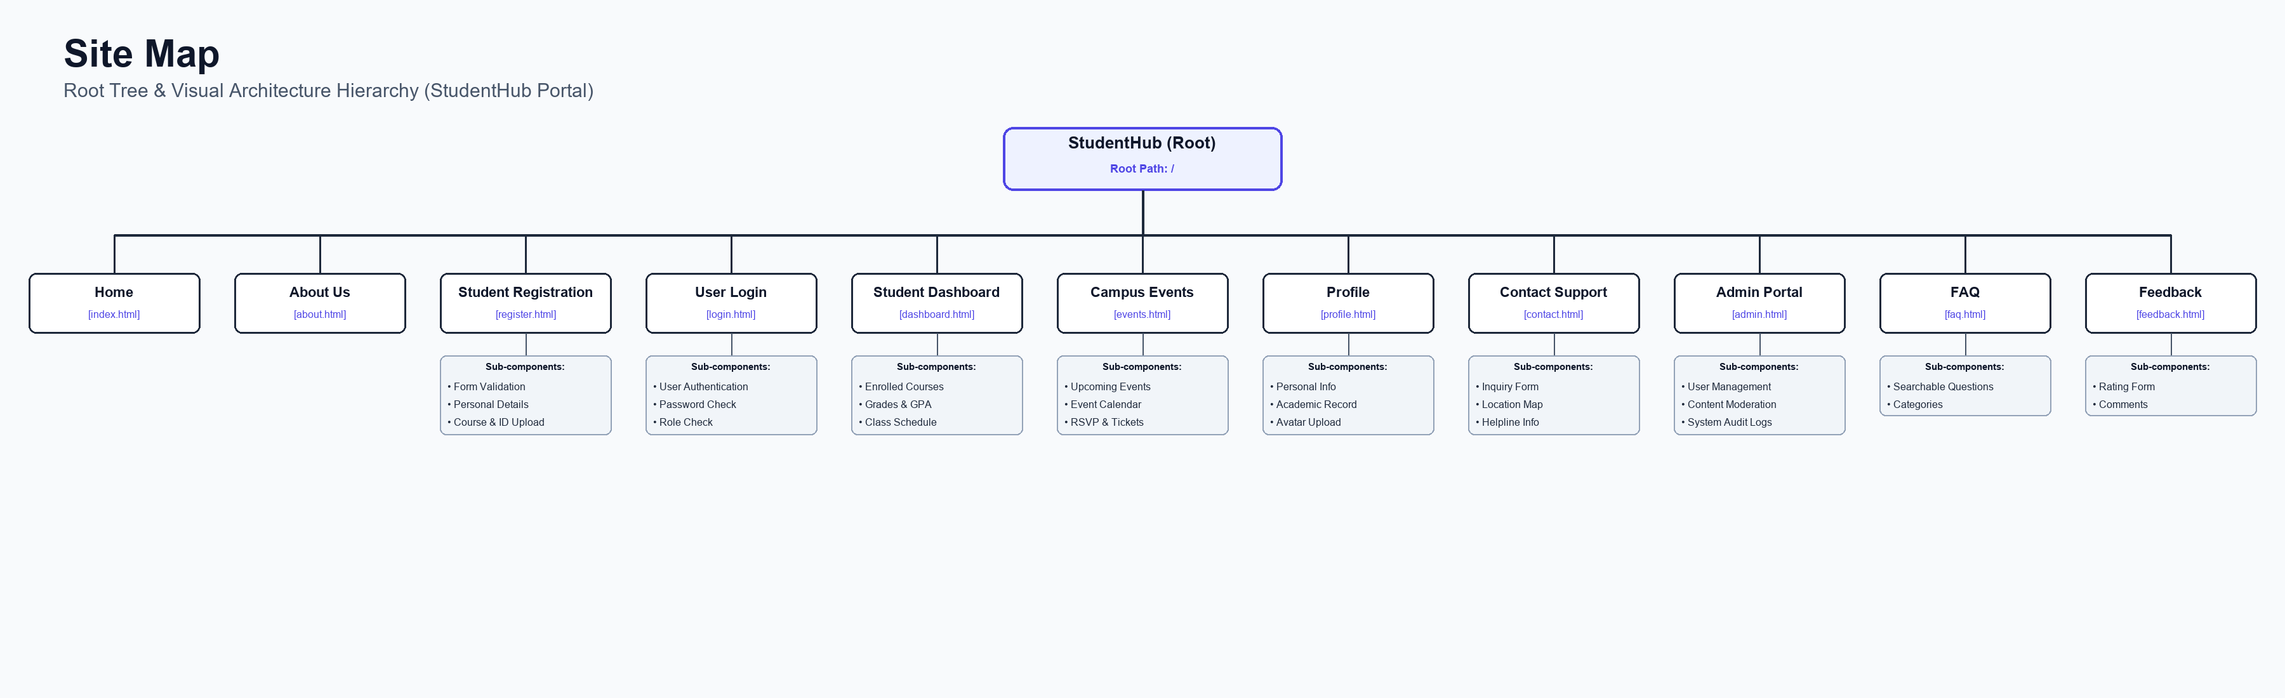
Figure: Visual Site Sitemap Design Hierarchy

Output Slot: Low-Fidelity Wireframes Collage
Figure: Low-Fidelity Visual Wireframe Collage

Output Slot: Individual Wireframes (All 11 Pages)

Wireframe: Home Page
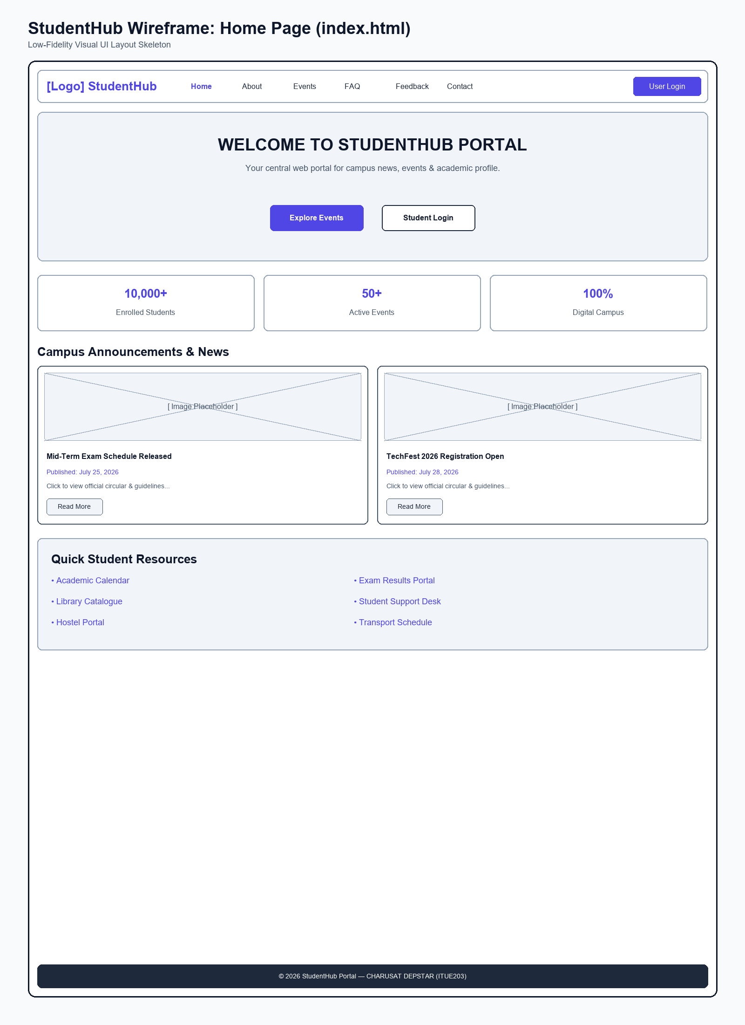
Figure: Wireframe layout of Home Page

Wireframe: About Us Page
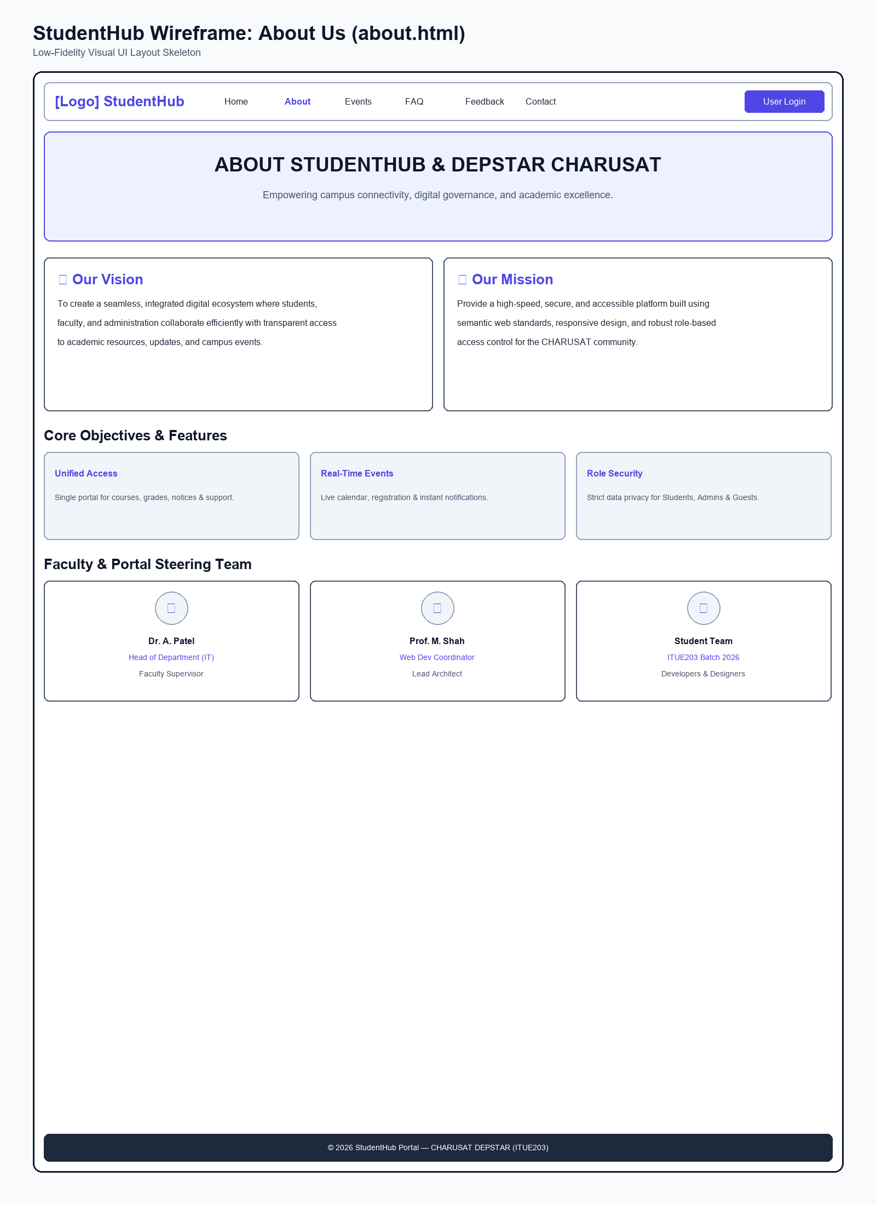
Figure: Wireframe layout of About Us Page

Wireframe: Student Registration Page
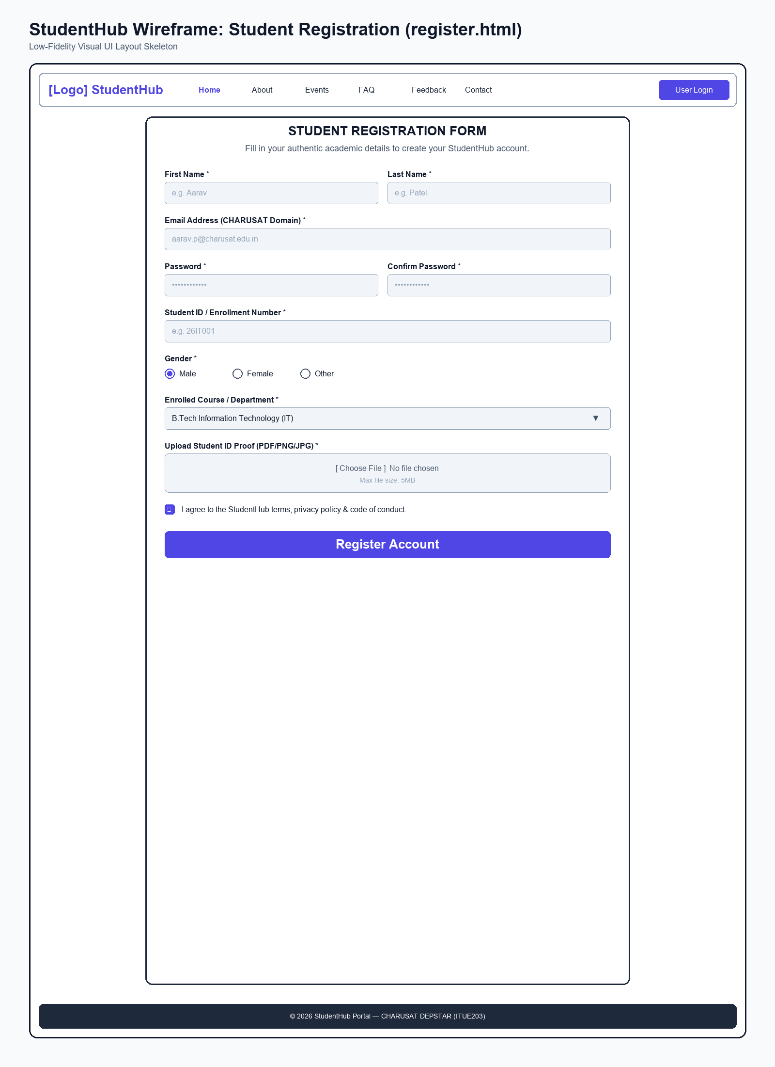
Figure: Wireframe layout of Student Registration Page

Wireframe: User Login Page
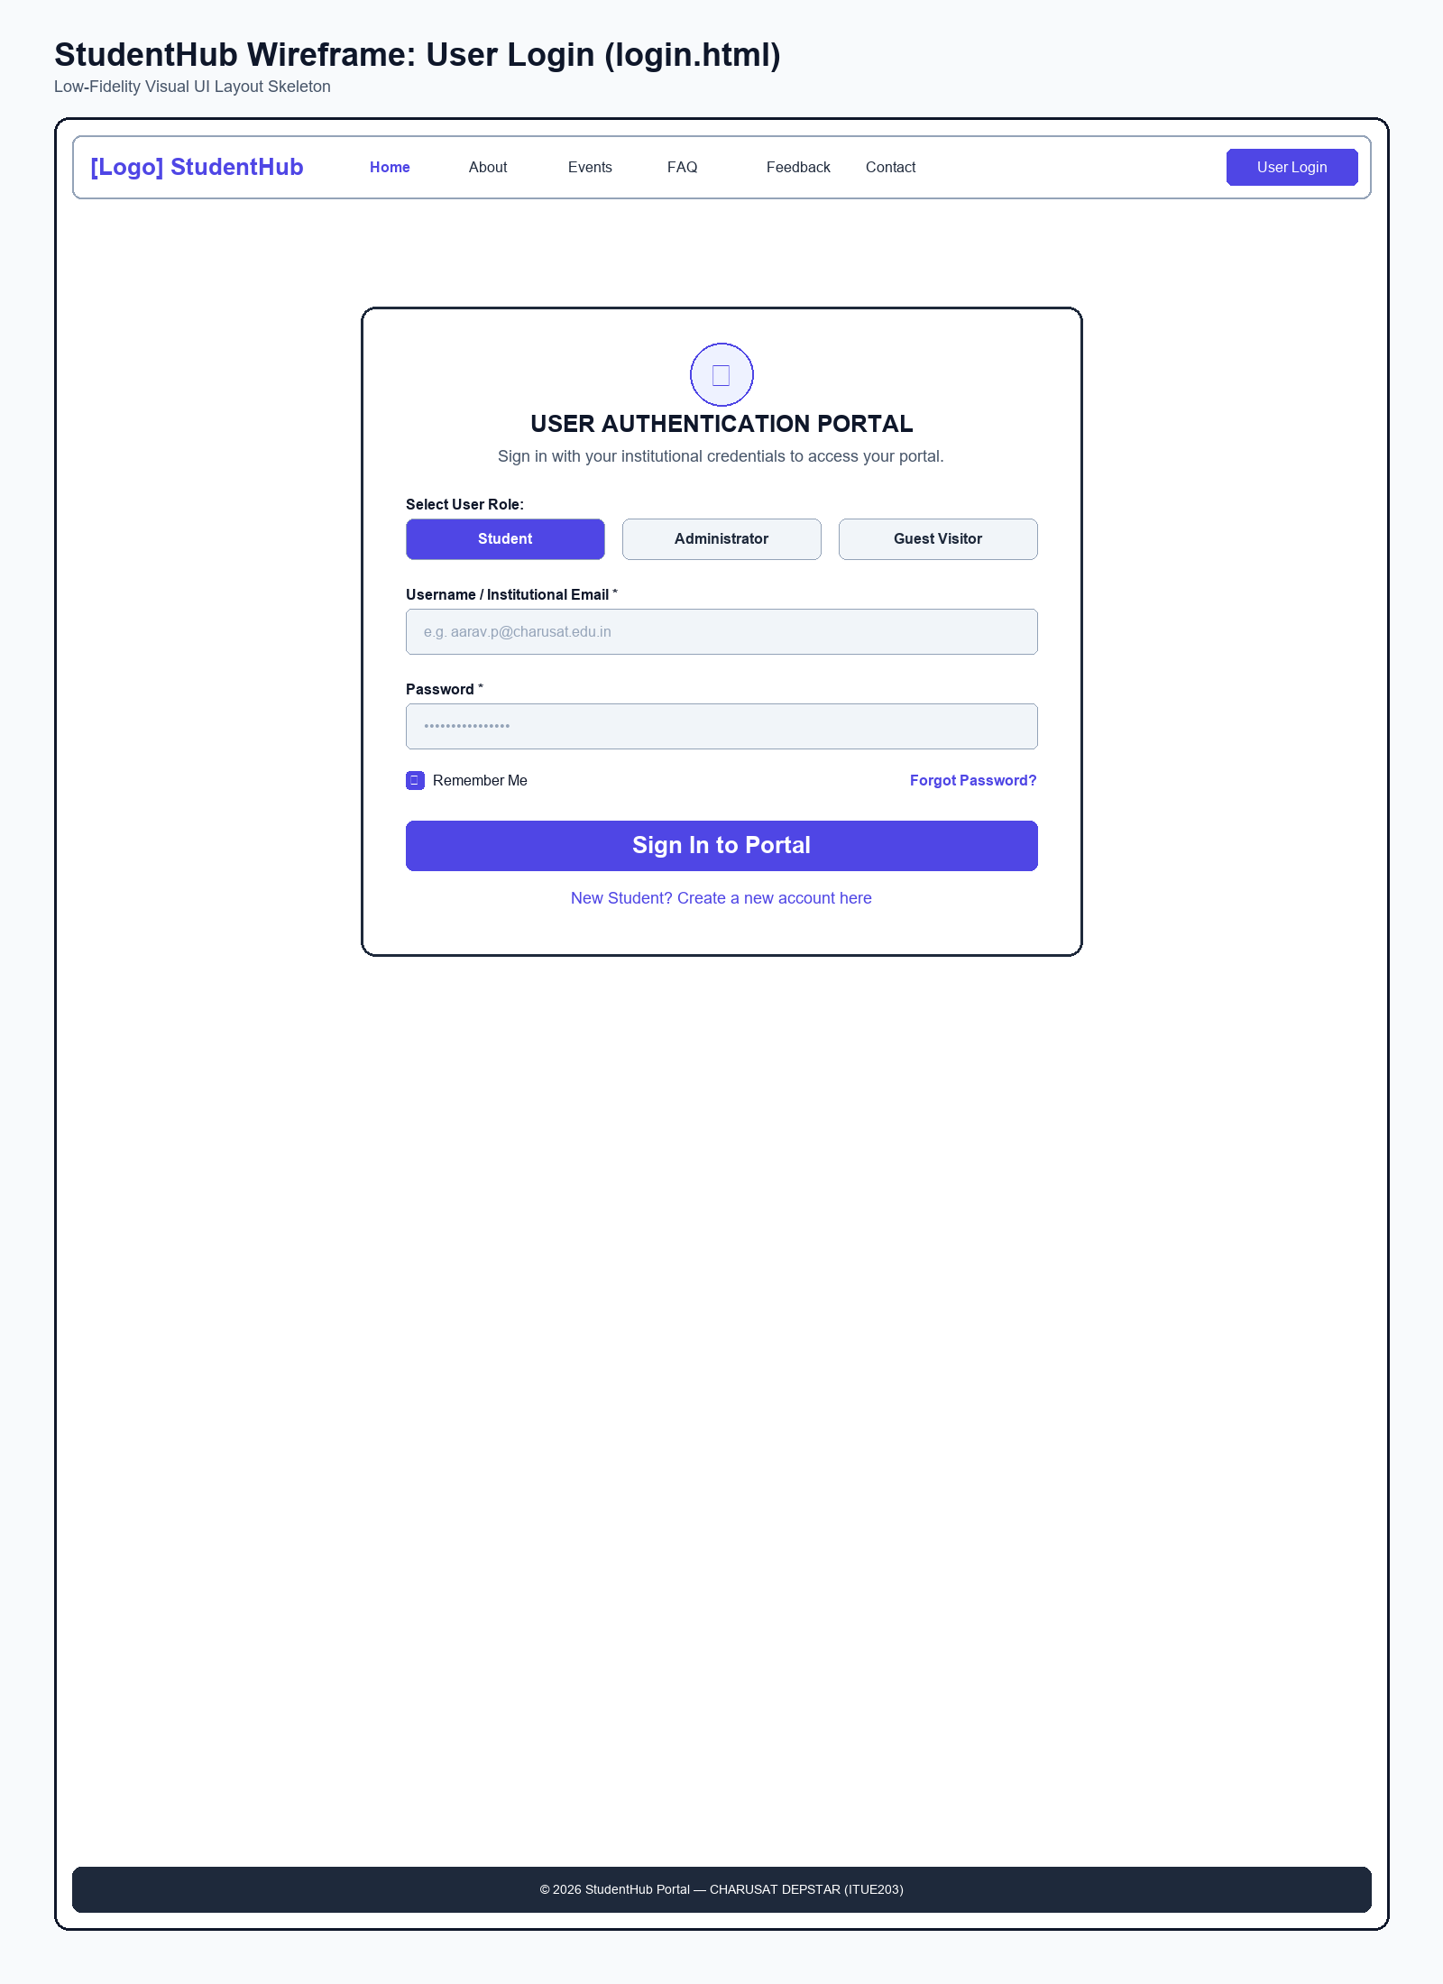
Figure: Wireframe layout of User Login Page

Wireframe: Student Dashboard Page
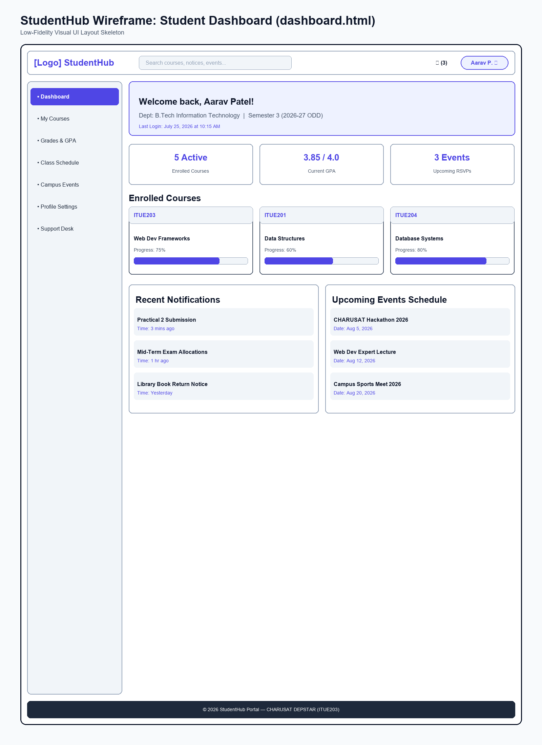
Figure: Wireframe layout of Student Dashboard Page

Wireframe: Campus Events Page
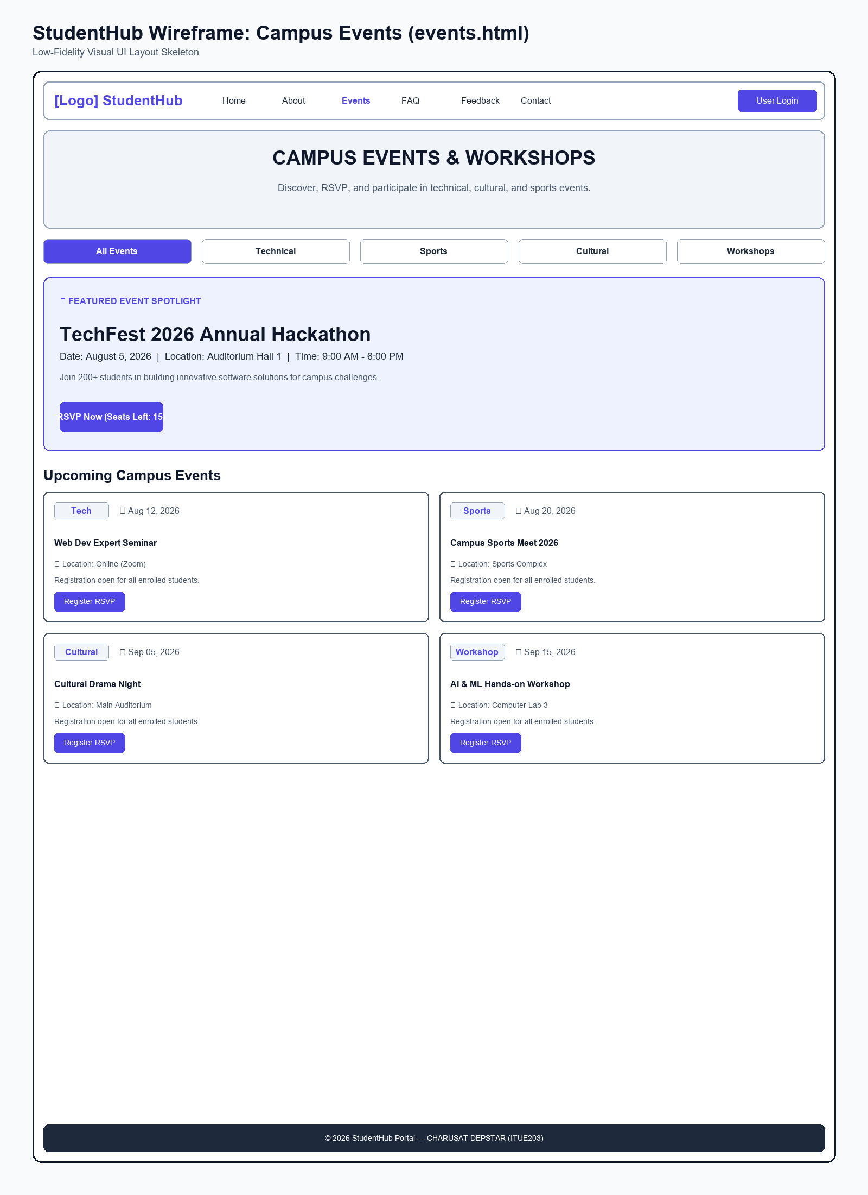
Figure: Wireframe layout of Campus Events Page

Wireframe: Student Profile Page
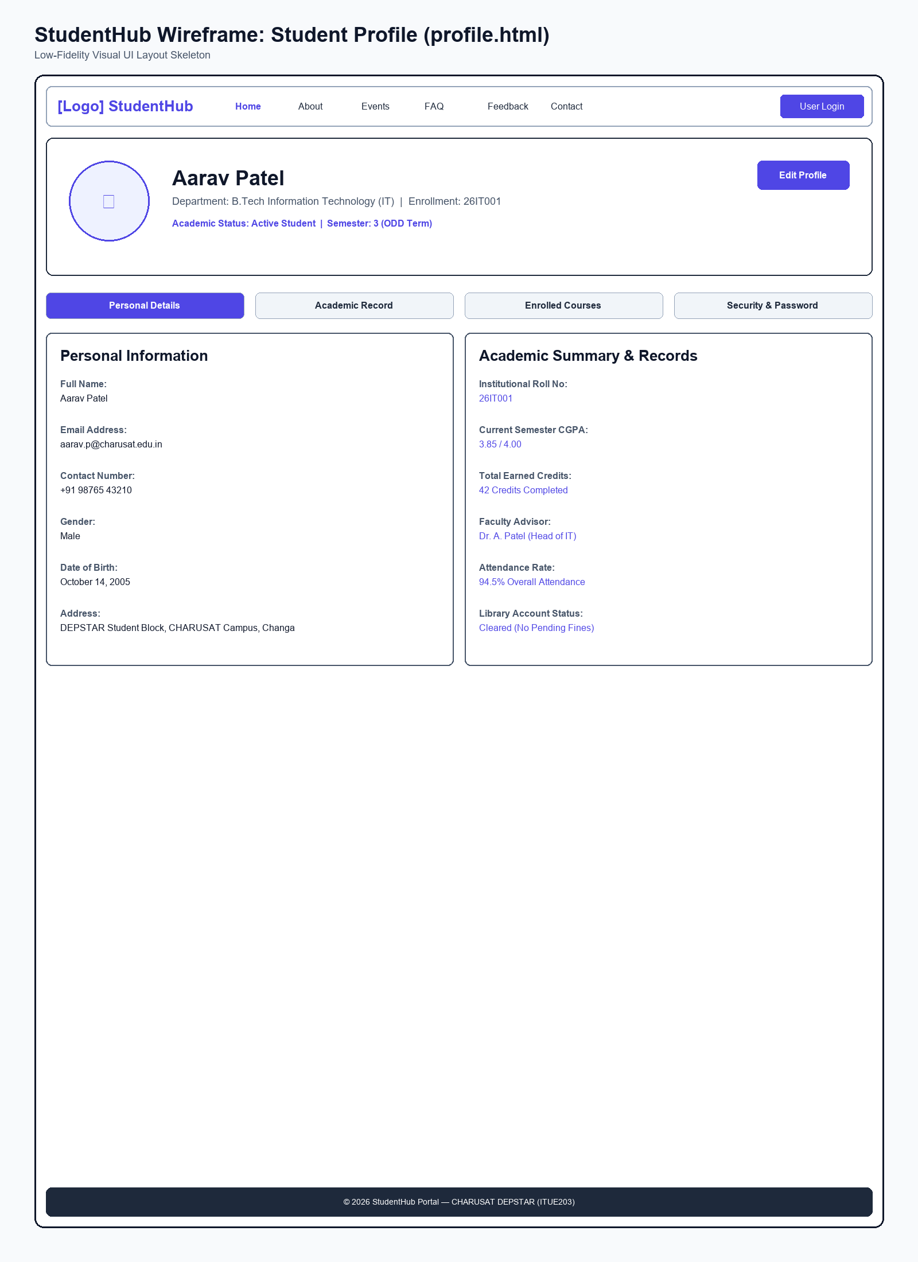
Figure: Wireframe layout of Student Profile Page

Wireframe: Contact Support Page
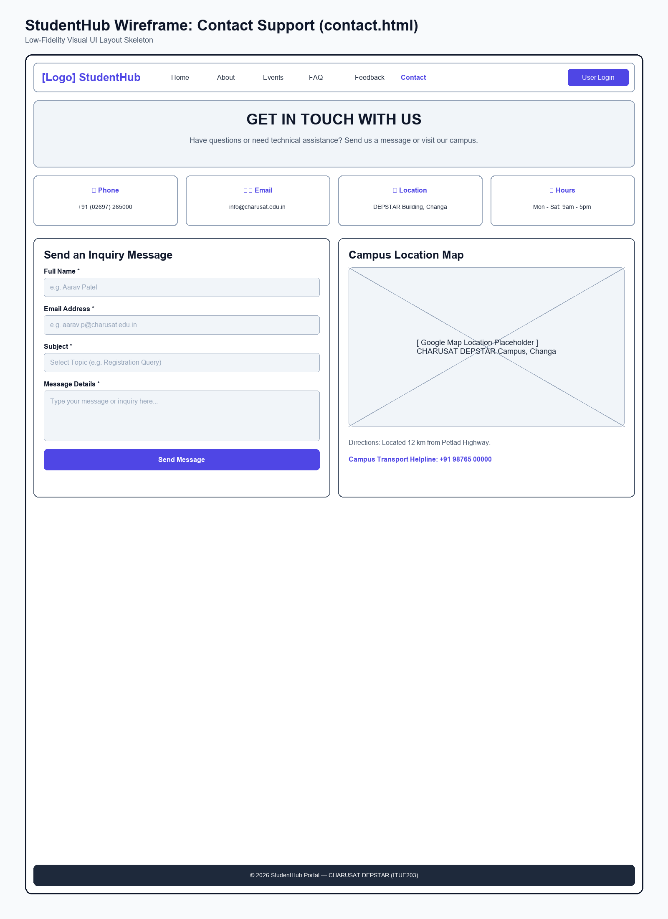
Figure: Wireframe layout of Contact Support Page

Wireframe: Admin Portal Page
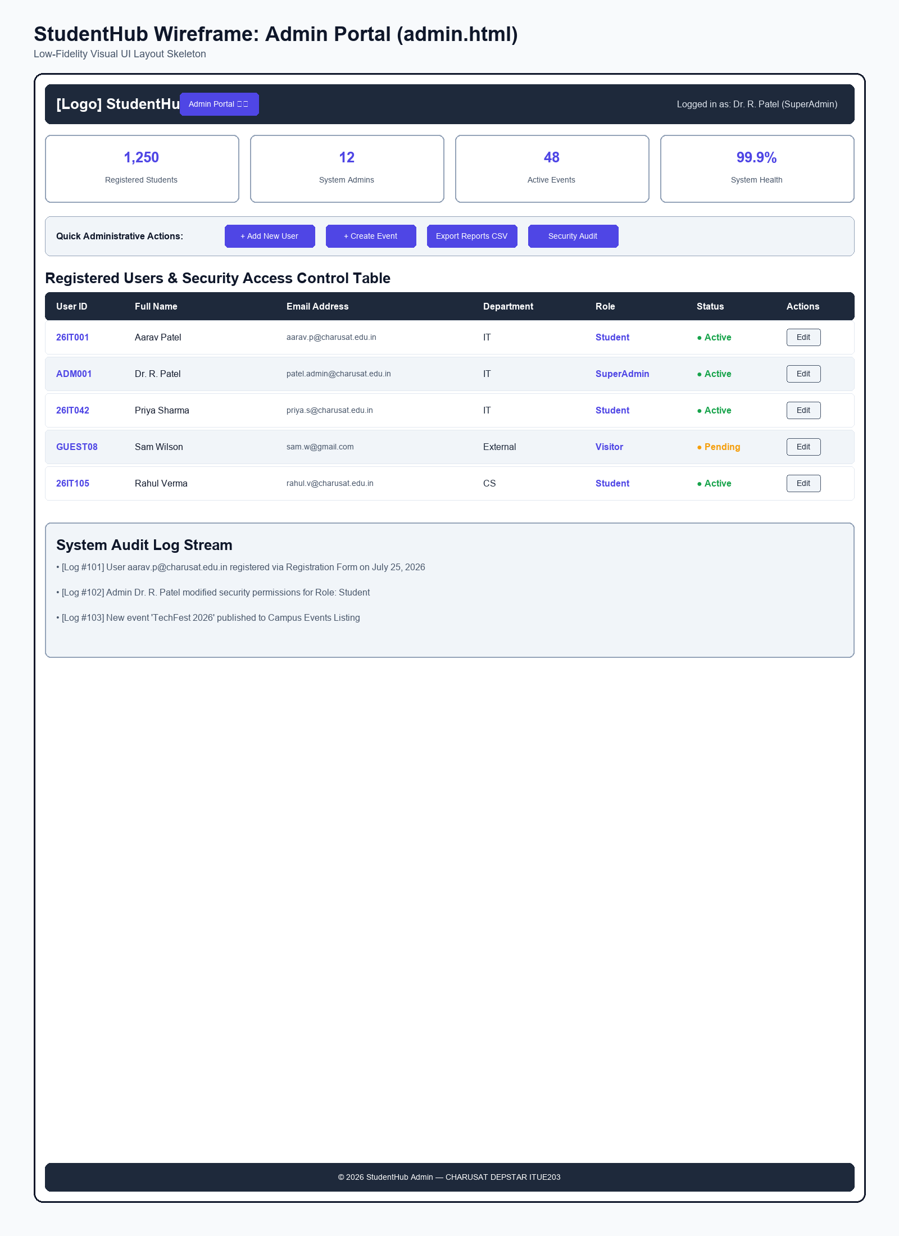
Figure: Wireframe layout of Admin Portal Page

Wireframe: FAQ Page
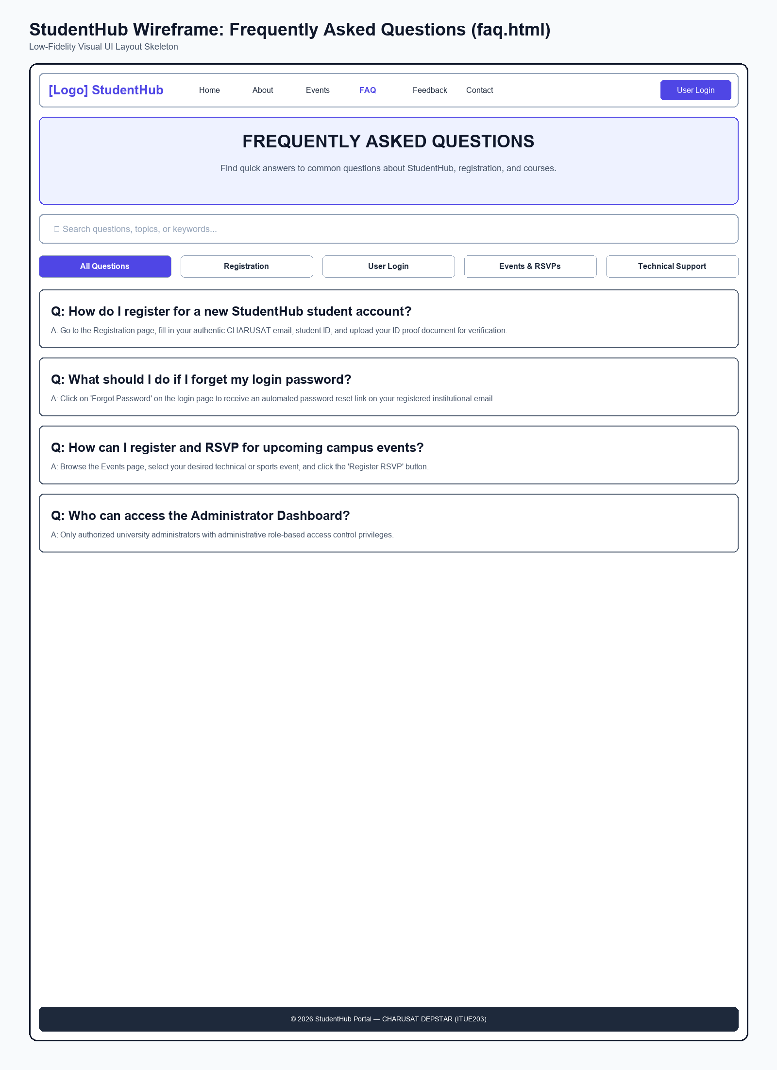
Figure: Wireframe layout of FAQ Page

Wireframe: Feedback Survey Page
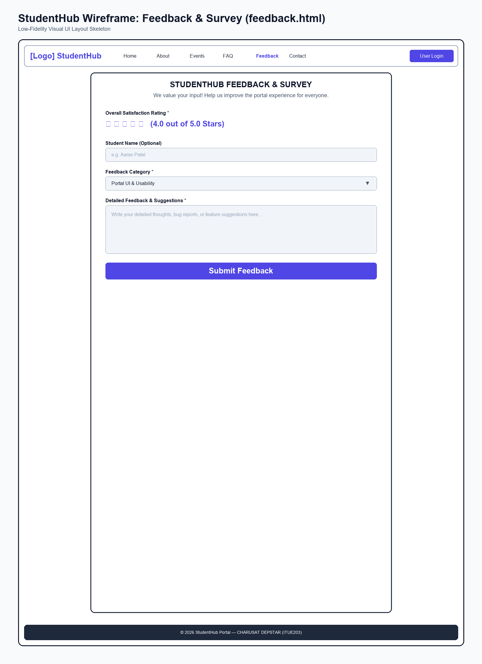
Figure: Wireframe layout of Feedback Survey Page

Output Slot: GitHub Repository & Commits Layout
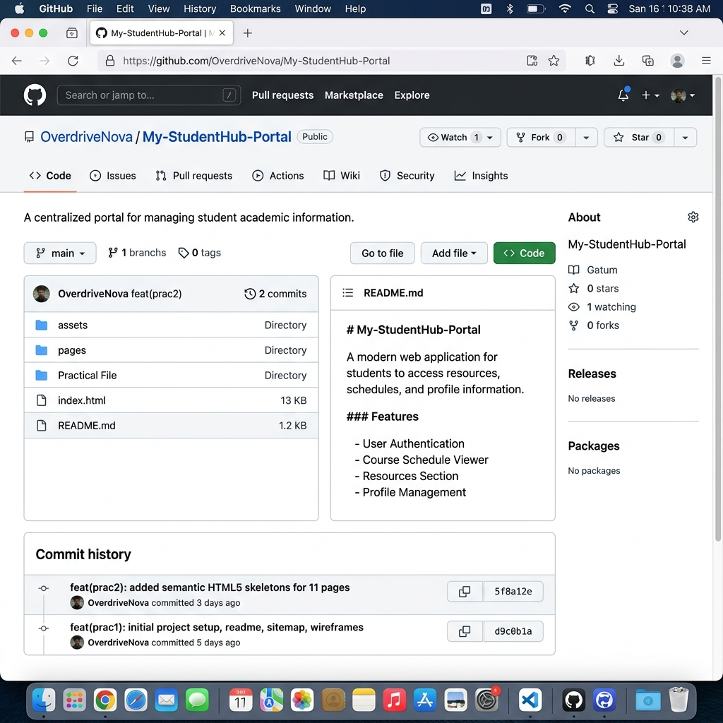
Figure: GitHub Repository Landing Page Showing Commit History

Output Slot: IDE Explorer Project Directory Layout
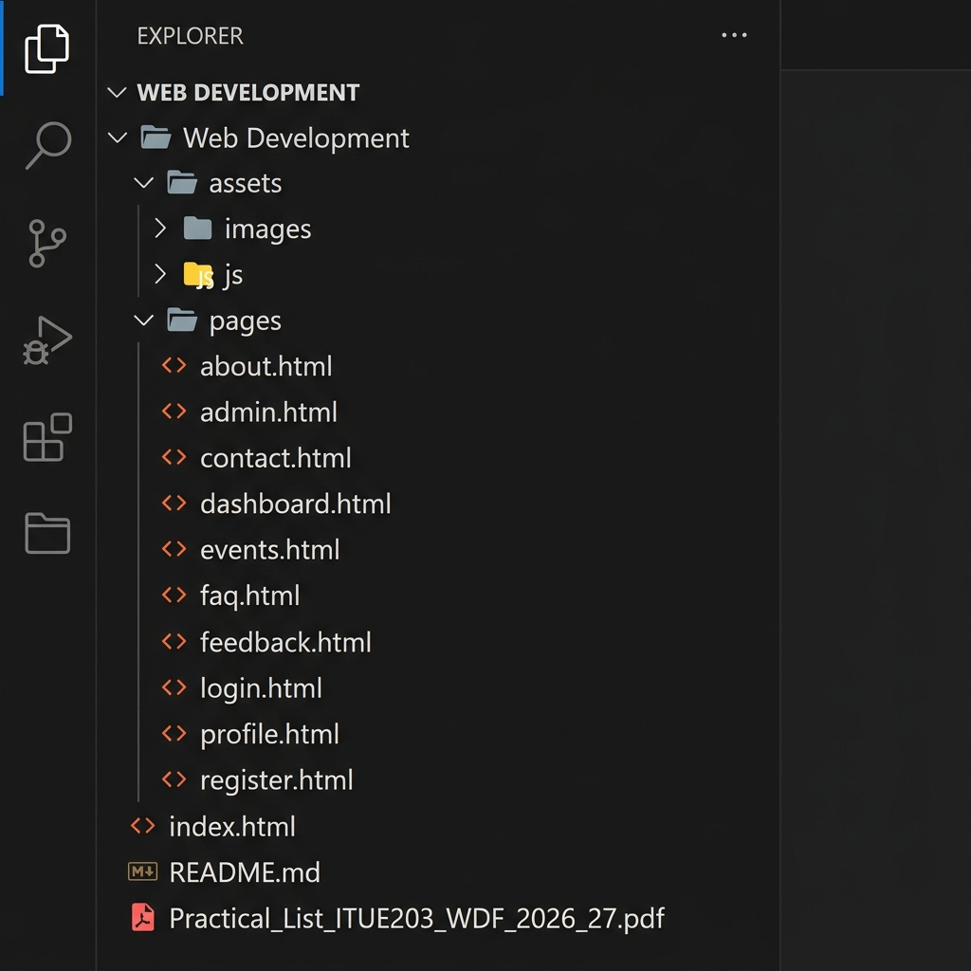
Figure: VS Code IDE Workspace File Explorer Tree

PRACTICAL NO: 2

AIM
Semantic HTML5 Pages with Accessibility-Ready Structure

PROBLEM DEFINITION
Develop static HTML5 skeletons for at least 10 StudentHub pages such as Home, About, Register, Login, Dashboard, Events, Profile, Contact, Admin, FAQ, and Feedback. Use semantic tags and accessibility-friendly structure.

KEY QUESTIONS & INTERPRETATION
Q1: Are semantic tags such as <header>, <nav>, <main>, <section>, <article>, <aside>, and <footer> used properly?
Yes. The tags are applied following their semantic definitions:
• <header> wraps the introductory content (site name, course title, and institute logo).
• <nav> is used exclusively for primary navigation blocks and breadcrumbs.
• <main> holds the primary, unique content of each page, marking it for screen readers and keyboard skip links.
• <section> groups related thematic content block elements.
• <article> wraps self-contained content modules (like news announcements or specific event entries).
• <aside> represents tangential or supplementary information (such as registration notices, map widgets, and support logs).
• <footer> represents page metadata, copyrights, and return-to-top links.
Q2: Are form labels, headings, image alt text, and navigation links accessible?
Yes. Accessibility features implemented include:
1. Explicit Form Labels: Every input control is wrapped in or mapped directly to a <label> element using matching 'for' and 'id' properties to support screen reader text-to-speech.
2. Logical Headings: Headings follow a strict descending hierarchy (e.g. <h1> -> <h2> -> <h3>) with exactly one <h1> per page.
3. Descriptive Alt Text: All images contain informative descriptive attributes (e.g. alt="Web Innovation Hackathon Banner").
4. Skip-to-Content & Focus Ring: Screen readers and keyboard-only users can jump directly to the unique body contents using the "Skip to main content" shortcut.
Q3: Is the page structure consistent across all pages?
Yes, all 11 pages share the exact same structural template (Header -> Navigation -> Breadcrumbs -> Main Content containing sections/asides -> Footer), ensuring a highly predictable and easy-to-use user experience.

ACCESSIBILITY CHECKLIST IMPLEMENTED
✓ Skip-to-Content: A skip-to-content link exists as the very first child of <body> on all 11 pages.
✓ Accessible Main Target: Every <main> container has id="main-content" and tabindex="-1" to properly capture screen reader focus.
✓ Breadcrumb Navigation: Breadcrumbs are added just below the main navigation lists to support intermediate site tracking.
✓ Keyboard-Friendly Outlines: Focus indicators (:focus) are clearly styled by standard browser outline behavior to maintain accessibility.
✓ Semantic Tags: A complete set of semantic tags (<header>, <nav>, <main>, <section>, <article>, <aside>, <footer>) is used correctly across all pages.
✓ Explicit Form Labels: All input, select, and textarea fields are explicitly bound to corresponding labels.
✓ Language Attribute: Every document contains <html lang="en"> to set the screen reader language dictionary.
✓ Descriptive Alt Attributes: All site images contain readable, contextual alternative text descriptions.
✓ SEO Meta Descriptions: Proper page titles and specific search descriptions are set in every document head.

IMPLEMENTATION CODE (All 11 Pages)
Below is the complete semantic HTML5 source code for all pages of the portal:

Source Code: index.html (Home Page)
<!DOCTYPE html>
<html lang="en">
<head>
<meta charset="UTF-8">
<meta name="viewport" content="width=device-width, initial-scale=1.0">
<meta name="description" content="StudentHub - Central Campus Portal for CHARUSAT Students">
<title>StudentHub - Home Page</title>
</head>
<body>
<!-- Skip to Main Content Link for Keyboard Accessibility -->
<a href="#main-content" class="skip-link">Skip to main content</a>
<!-- Lesson 1: Document Structure & Header -->
<header>
<h1>StudentHub Central Portal</h1>
<p><strong>Charotar University of Science and Technology (CHARUSAT)</strong></p>
<p><small>Devang Patel Institute of Advance Technology &amp; Research | Course: <em>ITUE203 - Web Development Frameworks</em></small></p>
</header>
<hr>
<!-- Lesson 3: Internal Navigation Menu -->
<nav aria-label="Main Navigation Menu">
<h2>Portal Quick Navigation</h2>
<ul>
<li><a href="index.html">Home</a></li>
<li><a href="pages/about.html">About Us</a></li>
<li><a href="pages/register.html">Student Registration</a></li>
<li><a href="pages/login.html">User Login</a></li>
<li><a href="pages/dashboard.html">Student Dashboard</a></li>
<li><a href="pages/events.html">Campus Events</a></li>
<li><a href="pages/profile.html">Student Profile</a></li>
<li><a href="pages/contact.html">Contact Support</a></li>
<li><a href="pages/admin.html">Admin Portal</a></li>
<li><a href="pages/faq.html">FAQ</a></li>
<li><a href="pages/feedback.html">Feedback Survey</a></li>
</ul>
</nav>
<hr>
<!-- Breadcrumb Navigation -->
<nav aria-label="Breadcrumb" class="breadcrumbs">
<ul>
<li><a href="index.html" aria-current="page">Home</a></li>
</ul>
</nav>
<hr>
<!-- Lesson 6: Quick Portal Search Form -->
<section>
<h2>Portal Quick Search</h2>
<form action="index.html" method="get">
<p>
<label for="site-search">Search Portal Content:</label>
<input type="search" id="site-search" name="q" placeholder="Search events, courses, FAQs..." required minlength="2" maxlength="50">
<button type="submit">Search</button>
<button type="reset">Clear</button>
</p>
</form>
</section>
<hr>
<!-- Lesson 2: Headings, Text Formatting, Elements -->
<main id="main-content" tabindex="-1">
<section id="welcome-section">
<h2>Welcome to StudentHub</h2>
<p>
StudentHub is an <strong>integrated academic management system</strong> designed to assist students in tracking their <em>academic schedule</em>, registering for <u>campus hackathons</u>, and maintaining their official profile.
</p>
<p>
<mark>Important Notice:</mark> Registration for the 2026<sup>th</sup> Academic Cycle (Semester 3) is currently <strong>ACTIVE</strong>.
</p>
<!-- Lesson 3: Image with relative/absolute paths & security/privacy attributes -->
<p>
<img src="https://via.placeholder.com/600x200.png?text=CHARUSAT+StudentHub+Campus+Portal"
alt="CHARUSAT Campus Banner Placeholder"
width="600"
height="200"
loading="lazy"
referrerpolicy="no-referrer">
</p>
</section>
<section id="announcements">
<h2>Latest Campus Announcements</h2>
<article>
<h3>1. Mid-Semester Examination Schedule <small>(Academic Update)</small></h3>
<p>Published on: <ins>July 24, 2026</ins> | Author: <b>Academic Section</b></p>
<p>
The mid-semester timetable for 3<sup>rd</sup> semester B.Tech students has been published.
Please check the <a href="pages/dashboard.html#schedule">Dashboard Schedule</a> for room allocations.
</p>
<p>
<del>Old Exam Start Date: August 1, 2026</del><br>
<strong>Revised Exam Start Date: August 5, 2026</strong>
</p>
</article>
<br>
<article>
<h3>2. Annual Web Hackathon 2026</h3>
<p>Published on: <ins>July 20, 2026</ins> | Category: <i>Technical Competition</i></p>
<p>
Participants must build responsive web projects using standard HTML elements.
Registration closes on <mark>August 2, 2026</mark>.
Visit the <a href="pages/events.html">Campus Events Page</a> to register your team.
</p>
</article>
</section>
<hr>
<!-- Lesson 4: Unordered and Nested Lists -->
<section id="portal-highlights">
<h2>Key Portal Services</h2>
<ul>
<li><strong>Academic Management</strong>
<ul>
<li>View course enrollment list</li>
<li>Check examination schedules &amp; results</li>
</ul>
</li>
<li><strong>Campus Activities</strong>
<ul>
<li>Technical workshops &amp; seminars</li>
<li>Cultural and sports event registration</li>
</ul>
</li>
<li><strong>Student Support</strong>
<ul>
<li>Direct inquiry submission</li>
<li>Frequently Asked Questions (<a href="pages/faq.html">FAQ</a>)</li>
</ul>
</li>
</ul>
</section>
<hr>
<!-- Lesson 3: External Links with Security Attributes -->
<aside id="external-resources">
<h2>External University Links</h2>
<p>
Visit the official website:
<a href="https://www.charusat.ac.in" target="_blank" rel="noopener noreferrer">CHARUSAT Official Portal</a>
<small>(Opens in a new tab with <code>rel="noopener noreferrer"</code> for link security)</small>.
</p>
</aside>
</main>
<hr>
<!-- Lesson 1 & 2: Footer & Contact Info -->
<footer>
<p><small>&copy; 2026 StudentHub Portal | CHARUSAT DEPSTAR - ITUE203</small></p>
<p><small><a href="#welcome-section">Back to Top of Page</a></small></p>
</footer>
</body>
</html>

Source Code: pages/about.html (About Us Page)
<!DOCTYPE html>
<html lang="en">
<head>
<meta charset="UTF-8">
<meta name="viewport" content="width=device-width, initial-scale=1.0">
<meta name="description" content="About StudentHub - Vision, Department Details, and Academic Syllabus Table">
<title>StudentHub - About Portal</title>
</head>
<body>
<!-- Skip to Main Content Link for Keyboard Accessibility -->
<a href="#main-content" class="skip-link">Skip to main content</a>
<!-- Lesson 1: Header -->
<header>
<h1>About StudentHub Portal</h1>
<p><strong>Charotar University of Science and Technology (CHARUSAT)</strong></p>
<p><small>Devang Patel Institute of Advance Technology &amp; Research | Department of Information Technology</small></p>
</header>
<hr>
<!-- Lesson 3: Navigation -->
<nav aria-label="Main Navigation Menu">
<h2>Portal Quick Navigation</h2>
<ul>
<li><a href="../index.html">Home</a></li>
<li><a href="about.html">About Us</a></li>
<li><a href="register.html">Student Registration</a></li>
<li><a href="login.html">User Login</a></li>
<li><a href="dashboard.html">Dashboard</a></li>
<li><a href="events.html">Campus Events</a></li>
<li><a href="profile.html">Student Profile</a></li>
<li><a href="contact.html">Contact Support</a></li>
<li><a href="admin.html">Admin Portal</a></li>
<li><a href="faq.html">FAQ</a></li>
<li><a href="feedback.html">Feedback Survey</a></li>
</ul>
</nav>
<hr>
<!-- Breadcrumb Navigation -->
<nav aria-label="Breadcrumb" class="breadcrumbs">
<ul>
<li><a href="../index.html">Home</a></li>
<li><a href="about.html" aria-current="page">About Us</a></li>
</ul>
</nav>
<hr>
<main id="main-content" tabindex="-1">
<!-- Lesson 2: Headings & Text Formatting -->
<section id="vision">
<h2>Portal Vision &amp; Purpose</h2>
<p>
The <strong>StudentHub</strong> platform is designed specifically for students enrolled in the <em>Web Development Frameworks (ITUE203)</em> course during the 3<sup>rd</sup> semester (2026-27 ODD term).
</p>
<p>
<mark>Core Objective:</mark> To provide hands-on experience in building structural, accessible HTML5 applications using valid semantic elements, accessible tables, and structured forms.
</p>
</section>
<hr>
<!-- Lesson 4: Ordered Lists with attributes (type, start, reversed) & Nested Lists -->
<section id="objectives">
<h2>Course Learning Roadmap</h2>
<h3>Primary Learning Modules (Numeric Order)</h3>
<ol type="1" start="1">
<li><strong>HTML Basics &amp; Document Structure</strong>
<ul>
<li>Doctype, HTML root, Head, Title, Meta elements</li>
<li>Empty elements (<code>&lt;hr&gt;</code>, <code>&lt;br&gt;</code>, <code>&lt;img&gt;</code>, <code>&lt;input&gt;</code>)</li>
</ul>
</li>
<li><strong>Semantic Text Elements &amp; Formatting</strong>
<ul>
<li>Headings (<code>&lt;h1&gt;</code> to <code>&lt;h6&gt;</code>), Paragraphs, Formatting tags</li>
<li>Bold, Strong, Italic, Emphasis, Underline, Mark, Ins, Del, Sub, Sup</li>
</ul>
</li>
<li><strong>Links, Media &amp; Lists</strong>
<ul>
<li>Hyperlinks, Relative/Absolute paths, Security (<code>rel="noopener"</code>)</li>
<li>Unordered, Ordered, and Nested list structures</li>
</ul>
</li>
<li><strong>Data Tables &amp; Input Forms</strong>
<ul>
<li>Table rows, headers, cells, captions, <code>colspan</code>, <code>rowspan</code></li>
<li>Form inputs, validation attributes, dropdowns, buttons</li>
</ul>
</li>
</ol>
<h3>Development Milestones Timeline (Alphabetical, Reversed)</h3>
<ol type="A" reversed>
<li>Final Deployment &amp; Review</li>
<li>Backend Connection &amp; Data Integration</li>
<li>UI Layout Structuring</li>
<li>Requirement Analysis &amp; Wireframing</li>
</ol>
</section>
<hr>
<!-- Lesson 5: Comprehensive Table demonstrating thead, tbody, tfoot, th, td, colspan, rowspan -->
<section id="syllabus-table">
<h2>Semester 3 Course Structure &amp; Assessment Table</h2>
<table border="1" cellpadding="6" cellspacing="0">
<caption><strong>Table 1: ITUE203 Web Development Frameworks Module Breakdown</strong></caption>
<thead>
<tr>
<th scope="col" rowspan="2">Module No.</th>
<th scope="col" rowspan="2">Module Name</th>
<th scope="col" colspan="2">Hours Allocation</th>
<th scope="col" rowspan="2">Evaluation Weightage (%)</th>
</tr>
<tr>
<th scope="col">Lecture</th>
<th scope="col">Practical</th>
</tr>
</thead>
<tbody>
<tr>
<th scope="row">Unit 1</th>
<td>HTML5 Basics, Text Formatting &amp; Navigation</td>
<td>4 Hours</td>
<td>6 Hours</td>
<td>15%</td>
</tr>
<tr>
<th scope="row">Unit 2</th>
<td>HTML Lists, Hyperlinks &amp; Media Handling</td>
<td>4 Hours</td>
<td>6 Hours</td>
<td>15%</td>
</tr>
<tr>
<th scope="row" rowspan="2">Unit 3</th>
<td>Complex HTML Data Tables (Colspan &amp; Rowspan)</td>
<td>3 Hours</td>
<td>4 Hours</td>
<td rowspan="2">30% <small>(Combined Unit 3)</small></td>
</tr>
<tr>
<td>Interactive HTML Forms &amp; Input Attributes</td>
<td>5 Hours</td>
<td>8 Hours</td>
</tr>
<tr>
<th scope="row">Unit 4</th>
<td>Project Integration &amp; Documentation</td>
<td>4 Hours</td>
<td>6 Hours</td>
<td>40%</td>
</tr>
</tbody>
<tfoot>
<tr>
<th scope="row" colspan="2">Total Academic Engagement</th>
<td><strong>20 Hours</strong></td>
<td><strong>30 Hours</strong></td>
<td><strong>100%</strong></td>
</tr>
</tfoot>
</table>
</section>
<hr>
<!-- Lesson 3: External Links -->
<aside id="external">
<h2>Department Contact &amp; Links</h2>
<p>
For official faculty guidelines, visit
<a href="https://www.charusat.ac.in/depstar" target="_blank" rel="noopener noreferrer">CHARUSAT DEPSTAR Portal</a>
or send an email to <a href="mailto:info@charusat.ac.in">info@charusat.ac.in</a>.
</p>
</aside>
</main>
<hr>
<footer>
<p><small>&copy; 2026 StudentHub | <a href="../index.html">Return to Home Page</a></small></p>
</footer>
</body>
</html>

Source Code: pages/register.html (Student Registration Page)
<!DOCTYPE html>
<html lang="en">
<head>
<meta charset="UTF-8">
<meta name="viewport" content="width=device-width, initial-scale=1.0">
<meta name="description" content="Student Registration Form - Demonstrating Lesson 6 HTML Form Inputs and Attributes">
<title>StudentHub - Registration</title>
</head>
<body>
<!-- Skip to Main Content Link for Keyboard Accessibility -->
<a href="#main-content" class="skip-link">Skip to main content</a>
<!-- Lesson 1: Header -->
<header>
<h1>Student Registration Portal</h1>
<p><strong>Charotar University of Science and Technology (CHARUSAT)</strong></p>
<p><small>Course: <em>ITUE203 - Web Development Frameworks</em> | Lesson 6 Form Demonstration</small></p>
</header>
<hr>
<!-- Lesson 3: Navigation -->
<nav aria-label="Main Navigation Menu">
<h2>Portal Quick Navigation</h2>
<ul>
<li><a href="../index.html">Home</a></li>
<li><a href="about.html">About Us</a></li>
<li><a href="register.html">Student Registration</a></li>
<li><a href="login.html">User Login</a></li>
<li><a href="dashboard.html">Dashboard</a></li>
<li><a href="events.html">Campus Events</a></li>
<li><a href="profile.html">Student Profile</a></li>
<li><a href="contact.html">Contact Support</a></li>
<li><a href="admin.html">Admin Portal</a></li>
<li><a href="faq.html">FAQ</a></li>
<li><a href="feedback.html">Feedback Survey</a></li>
</ul>
</nav>
<hr>
<!-- Breadcrumb Navigation -->
<nav aria-label="Breadcrumb" class="breadcrumbs">
<ul>
<li><a href="../index.html">Home</a></li>
<li><a href="register.html" aria-current="page">Student Registration</a></li>
</ul>
</nav>
<hr>
<main id="main-content" tabindex="-1">
<section id="registration-section">
<h2>New Student Registration Form</h2>
<p>
<small>Fields marked with <strong>*</strong> are mandatory for account creation.</small>
</p>
<!-- Lesson 6: Comprehensive Form showcasing action, method, and input types/attributes -->
<form action="register.html" method="post" enctype="multipart/form-data">
<!-- Hidden Input -->
<input type="hidden" id="form_id" name="form_id" value="REG_FORM_2026_V1">
<input type="hidden" id="academic_year" name="academic_year" value="2026-2027">
<!-- System Metadata (Readonly & Disabled Input Types) -->
<fieldset>
<legend><strong>System Metadata (Readonly &amp; Disabled Inputs)</strong></legend>
<p>
<label for="system_code">University Code (Readonly):</label><br>
<input type="text" id="system_code" name="system_code" value="CHARUSAT-DEPSTAR-ITUE203" readonly size="30">
</p>
<p>
<label for="auto_id">Generated Tracking ID (Disabled):</label><br>
<input type="text" id="auto_id" name="auto_id" value="AUTO-REG-99410" disabled size="30">
</p>
</fieldset>
<br>
<!-- Personal Information -->
<fieldset>
<legend><strong>Personal &amp; Contact Details</strong></legend>
<!-- Text Input -->
<p>
<label for="fullname">Full Name *:</label><br>
<input type="text"
id="fullname"
name="fullname"
placeholder="e.g., Aarav Patel"
required
minlength="3"
maxlength="50">
</p>
<!-- Email Input -->
<p>
<label for="email">CHARUSAT Email Address *:</label><br>
<input type="email"
id="email"
name="email"
placeholder="e.g., 26it001@charusat.edu.in"
required>
</p>
<!-- Password Inputs -->
<p>
<label for="password">Create Password *:</label><br>
<input type="password"
id="password"
name="password"
required
minlength="8"
maxlength="20"
placeholder="Minimum 8 characters">
</p>
<p>
<label for="confirm_password">Confirm Password *:</label><br>
<input type="password"
id="confirm_password"
name="confirm_password"
required
minlength="8"
maxlength="20"
placeholder="Re-enter password">
</p>
<!-- Telephone Input -->
<p>
<label for="phone">Mobile Phone Number *:</label><br>
<input type="tel"
id="phone"
name="phone"
placeholder="10-digit mobile number"
required
minlength="10"
maxlength="10">
</p>
<!-- Number Input -->
<p>
<label for="age">Age (Years) *:</label><br>
<input type="number"
id="age"
name="age"
value="18"
min="16"
max="60"
required>
</p>
<!-- Date Input -->
<p>
<label for="dob">Date of Birth *:</label><br>
<input type="date"
id="dob"
name="dob"
required>
</p>
<!-- Radio Buttons -->
<p>
<label>Gender *:</label><br>
<input type="radio" id="gender_male" name="gender" value="Male" required>
<label for="gender_male">Male</label>
<input type="radio" id="gender_female" name="gender" value="Female">
<label for="gender_female">Female</label>
<input type="radio" id="gender_other" name="gender" value="Other">
<label for="gender_other">Other</label>
</p>
</fieldset>
<br>
<!-- Academic & Technical Profile -->
<fieldset>
<legend><strong>Academic Information &amp; Preferences</strong></legend>
<!-- Select / Dropdown -->
<p>
<label for="department">Select Department *:</label><br>
<select id="department" name="department" required>
<option value="">-- Select Department --</option>
<option value="IT">Department of Information Technology</option>
<option value="CE">Department of Computer Engineering</option>
<option value="CSE">Department of Computer Science &amp; Engineering</option>
<option value="EC">Department of Electronics &amp; Communication</option>
</select>
</p>
<p>
<label for="semester">Current Semester *:</label><br>
<select id="semester" name="semester" required>
<option value="Semester 3" selected>Semester 3 (2026-27)</option>
<option value="Semester 4">Semester 4</option>
<option value="Semester 5">Semester 5</option>
</select>
</p>
<!-- URL Input -->
<p>
<label for="portfolio_url">Personal Website / GitHub Profile URL:</label><br>
<input type="url"
id="portfolio_url"
name="portfolio_url"
placeholder="https://github.com/username">
</p>
<!-- File Input -->
<p>
<label for="id_document">Upload Student ID Card / Proof (PDF, PNG, JPG) *:</label><br>
<input type="file"
id="id_document"
name="id_document"
accept=".pdf, .png, .jpg, .jpeg"
required>
</p>
<!-- Checkboxes -->
<p>
<label>Select Technical Interests:</label><br>
<input type="checkbox" id="interest_html" name="interests[]" value="HTML5" checked>
<label for="interest_html">HTML5 Semantic Structure</label><br>
<input type="checkbox" id="interest_tables" name="interests[]" value="Tables">
<label for="interest_tables">Data Tables &amp; Forms</label><br>
<input type="checkbox" id="interest_git" name="interests[]" value="Git">
<label for="interest_git">Git &amp; Version Control</label>
</p>
<!-- Textarea -->
<p>
<label for="statement">Statement of Purpose / Bio (Max 200 characters):</label><br>
<textarea id="statement"
name="statement"
rows="4"
cols="50"
maxlength="200"
placeholder="Briefly describe your academic background..."></textarea>
</p>
</fieldset>
<br>
<!-- Terms & Buttons -->
<fieldset>
<legend><strong>Confirmation</strong></legend>
<p>
<input type="checkbox" id="terms_agree" name="terms_agree" value="Yes" required>
<label for="terms_agree">I declare that all information provided above is accurate and complete. *</label>
</p>
<!-- Form Buttons -->
<p>
<button type="submit">Submit Registration</button>
<button type="reset">Reset Form Fields</button>
<button type="button" onclick="alert('StudentHub Registration System V1.0')">Help / Info</button>
</p>
</fieldset>
</form>
</section>
<aside id="register-info">
<h3>Registration Support</h3>
<p>Already have a StudentHub account? <a href="login.html">Login to your dashboard here</a>.</p>
<p>If you encounter any issues during registration (such as invalid student ID upload or duplicate emails), please reach out to the <a href="contact.html">IT Helpdesk</a> immediately.</p>
</aside>
</main>
<hr>
<footer>
<p><small>&copy; 2026 StudentHub | <a href="../index.html">Return to Home Page</a></small></p>
</footer>
</body>
</html>

Source Code: pages/login.html (User Login Page)
<!DOCTYPE html>
<html lang="en">
<head>
<meta charset="UTF-8">
<meta name="viewport" content="width=device-width, initial-scale=1.0">
<meta name="description" content="User Login Page - StudentHub Portal">
<title>StudentHub - User Login</title>
</head>
<body>
<!-- Skip to Main Content Link for Keyboard Accessibility -->
<a href="#main-content" class="skip-link">Skip to main content</a>
<!-- Lesson 1: Header -->
<header>
<h1>User Authentication Portal</h1>
<p><strong>Charotar University of Science and Technology (CHARUSAT)</strong></p>
<p><small>Access Student &amp; Faculty Accounts</small></p>
</header>
<hr>
<!-- Lesson 3: Navigation -->
<nav aria-label="Main Navigation Menu">
<h2>Portal Quick Navigation</h2>
<ul>
<li><a href="../index.html">Home</a></li>
<li><a href="about.html">About Us</a></li>
<li><a href="register.html">Student Registration</a></li>
<li><a href="login.html">User Login</a></li>
<li><a href="dashboard.html">Dashboard</a></li>
<li><a href="events.html">Campus Events</a></li>
<li><a href="profile.html">Student Profile</a></li>
<li><a href="contact.html">Contact Support</a></li>
<li><a href="admin.html">Admin Portal</a></li>
<li><a href="faq.html">FAQ</a></li>
<li><a href="feedback.html">Feedback Survey</a></li>
</ul>
</nav>
<hr>
<!-- Breadcrumb Navigation -->
<nav aria-label="Breadcrumb" class="breadcrumbs">
<ul>
<li><a href="../index.html">Home</a></li>
<li><a href="login.html" aria-current="page">User Login</a></li>
</ul>
</nav>
<hr>
<main id="main-content" tabindex="-1">
<section id="login-section">
<h2>Account Login Form</h2>
<p>Please enter your registered CHARUSAT email address and password to sign in.</p>
<!-- Lesson 6: Login Form -->
<form action="dashboard.html" method="post">
<!-- Hidden Input token -->
<input type="hidden" id="login_token" name="login_token" value="SECURE_SESSION_TOKEN_2026">
<fieldset>
<legend><strong>Login Credentials</strong></legend>
<!-- Email Input -->
<p>
<label for="login_email">Registered Email Address *:</label><br>
<input type="email"
id="login_email"
name="email"
placeholder="e.g., student@charusat.edu.in"
required>
</p>
<!-- Password Input -->
<p>
<label for="login_password">Account Password *:</label><br>
<input type="password"
id="login_password"
name="password"
placeholder="Enter your password"
required
minlength="8"
maxlength="20">
</p>
<!-- Checkbox Input -->
<p>
<input type="checkbox" id="remember_session" name="remember_session" value="1" checked>
<label for="remember_session">Remember me on this browser session</label>
</p>
<!-- Buttons -->
<p>
<button type="submit">Log In to Dashboard</button>
<button type="reset">Clear Fields</button>
</p>
</fieldset>
</form>
<br>
<!-- Help Links -->
<aside id="login-support">
<h3>Need help accessing your account?</h3>
<ul>
<li>Forgot your password? Visit <a href="contact.html">Contact Support</a>.</li>
<li>New to StudentHub? <a href="register.html">Create a new student account</a>.</li>
<li>External Helpdesk: <a href="https://www.charusat.ac.in" target="_blank" rel="noopener noreferrer">CHARUSAT IT Helpdesk</a></li>
</ul>
</aside>
</section>
</main>
<hr>
<footer>
<p><small>&copy; 2026 StudentHub | <a href="../index.html">Return to Home Page</a></small></p>
</footer>
</body>
</html>

Source Code: pages/dashboard.html (Student Dashboard Page)
<!DOCTYPE html>
<html lang="en">
<head>
<meta charset="UTF-8">
<meta name="viewport" content="width=device-width, initial-scale=1.0">
<meta name="description" content="Student Dashboard - View Enrolled Courses, Timetable, and Academic Notices">
<title>StudentHub - Student Dashboard</title>
</head>
<body>
<!-- Skip to Main Content Link for Keyboard Accessibility -->
<a href="#main-content" class="skip-link">Skip to main content</a>
<!-- Lesson 1: Header -->
<header>
<h1>Student Academic Dashboard</h1>
<p><strong>Charotar University of Science and Technology (CHARUSAT)</strong></p>
<p><small>Semester 3 (2026-27 ODD Term) | Logged-in User: <b>Aarav Patel</b></small></p>
</header>
<hr>
<!-- Lesson 3: Navigation -->
<nav aria-label="Main Navigation Menu">
<h2>Portal Quick Navigation</h2>
<ul>
<li><a href="../index.html">Home</a></li>
<li><a href="about.html">About Us</a></li>
<li><a href="register.html">Student Registration</a></li>
<li><a href="login.html">User Login</a></li>
<li><a href="dashboard.html">Dashboard</a></li>
<li><a href="events.html">Campus Events</a></li>
<li><a href="profile.html">Student Profile</a></li>
<li><a href="contact.html">Contact Support</a></li>
<li><a href="admin.html">Admin Portal</a></li>
<li><a href="faq.html">FAQ</a></li>
<li><a href="feedback.html">Feedback Survey</a></li>
</ul>
</nav>
<hr>
<!-- Breadcrumb Navigation -->
<nav aria-label="Breadcrumb" class="breadcrumbs">
<ul>
<li><a href="../index.html">Home</a></li>
<li><a href="dashboard.html" aria-current="page">Dashboard</a></li>
</ul>
</nav>
<hr>
<!-- Lesson 3: Internal Page Jump Links (Anchors) -->
<section id="dashboard-anchors">
<h2>Dashboard Quick Jump Links</h2>
<p>Jump to section:
<a href="#student-info">Student Profile Summary</a> |
<a href="#courses">Enrolled Courses Table</a> |
<a href="#schedule">Weekly Schedule</a> |
<a href="#notices">Academic Notices</a>
</p>
</section>
<hr>
<main id="main-content" tabindex="-1">
<!-- Lesson 5: Profile Summary Table with Rowspan & Colspan -->
<section id="student-info">
<h2>Student Profile Summary</h2>
<table border="1" cellpadding="6" cellspacing="0">
<caption><strong>Table 1: Student Metadata &amp; Status</strong></caption>
<tbody>
<tr>
<th scope="row" rowspan="2">Student Identity</th>
<td><strong>Full Name:</strong> Aarav Patel</td>
<td><strong>ID Number:</strong> 26IT001</td>
</tr>
<tr>
<td><strong>Email:</strong> aarav.p@charusat.edu.in</td>
<td><strong>Status:</strong> <mark>Active Enrolled</mark></td>
</tr>
<tr>
<th scope="row">Academic Standing</th>
<td><strong>Department:</strong> Information Technology</td>
<td><strong>Term:</strong> Semester 3 (ODD)</td>
</tr>
<tr>
<th scope="row">Overall Progress</th>
<td colspan="2"><strong>Attendance Rate:</strong> 92% | <strong>Passed Credits:</strong> 24 / 24</td>
</tr>
</tbody>
</table>
</section>
<hr>
<!-- Lesson 5: Complex Course Schedule Data Table -->
<section id="courses">
<h2>Enrolled Modules (Semester 3)</h2>
<!-- Lesson 6: Search Filter Form -->
<form action="dashboard.html" method="get">
<p>
<label for="course-filter">Filter Enrolled Modules:</label>
<input type="search" id="course-filter" name="filter" placeholder="e.g., ITUE203" required>
<button type="submit">Filter List</button>
<button type="reset">Show All</button>
</p>
</form>
<table border="1" cellpadding="6" cellspacing="0">
<caption><strong>Table 2: Semester 3 Registered Subjects &amp; Credit Allocation</strong></caption>
<thead>
<tr>
<th scope="col">Subject Code</th>
<th scope="col">Subject Title</th>
<th scope="col">Faculty Instructor</th>
<th scope="col">Lecture Credits</th>
<th scope="col">Practical Credits</th>
<th scope="col">Total Credits</th>
</tr>
</thead>
<tbody>
<tr>
<th scope="row">ITUE203</th>
<td>Web Development Frameworks</td>
<td>Dr. A. Patel</td>
<td>2</td>
<td>2</td>
<td>4</td>
</tr>
<tr>
<th scope="row">ITUE201</th>
<td>Data Structures &amp; Algorithms</td>
<td>Prof. R. Shah</td>
<td>3</td>
<td>1</td>
<td>4</td>
</tr>
<tr>
<th scope="row">ITUE202</th>
<td>Database Management Systems</td>
<td>Dr. S. Mehta</td>
<td>3</td>
<td>1</td>
<td>4</td>
</tr>
<tr>
<th scope="row">MAUE201</th>
<td>Engineering Mathematics III</td>
<td>Prof. K. Joshi</td>
<td>3</td>
<td>0</td>
<td>3</td>
</tr>
</tbody>
<tfoot>
<tr>
<th scope="row" colspan="3">Total Credit Units Registered</th>
<td>11</td>
<td>4</td>
<td><strong>15 Credits</strong></td>
</tr>
</tfoot>
</table>
</section>
<hr>
<!-- Lesson 4: Ordered List with Roman Numerals (type="I") -->
<section id="schedule">
<h2>Weekly Academic Schedule (Lab &amp; Practical Order)</h2>
<ol type="I">
<li><strong>Monday &amp; Wednesday:</strong> Web Development Frameworks (ITUE203) - Computer Lab 3 (09:00 AM - 11:00 AM)</li>
<li><strong>Tuesday:</strong> Database Management Systems (ITUE202) - Computer Lab 1 (11:15 AM - 01:15 PM)</li>
<li><strong>Thursday:</strong> Data Structures &amp; Algorithms Lab - Computer Lab 2 (02:00 PM - 04:00 PM)</li>
<li><strong>Friday:</strong> Engineering Mathematics Tutorial - Lecture Hall 102 (10:00 AM - 11:00 AM)</li>
</ol>
</section>
<hr>
<!-- Lesson 2: Formatting Elements & Paragraphs -->
<aside id="notices">
<h2>Academic Notices for Aarav Patel</h2>
<ul>
<li>
<strong>Practical Submission Reminder:</strong>
Practical 1 &amp; Practical 2 HTML files must be uploaded to GitHub before <ins>August 2, 2026</ins>.
</li>
<li>
<strong>Workshop Invitation:</strong>
Web Innovation Hackathon details are posted on the <a href="events.html">Campus Events Page</a>.
</li>
</ul>
</aside>
</main>
<hr>
<footer>
<p><small>&copy; 2026 StudentHub | <a href="../index.html">Return to Home Page</a></small></p>
</footer>
</body>
</html>

Source Code: pages/events.html (Campus Events Page)
<!DOCTYPE html>
<html lang="en">
<head>
<meta charset="UTF-8">
<meta name="viewport" content="width=device-width, initial-scale=1.0">
<meta name="description" content="Campus Events Listing - Technical Hackathons, Workshops, and Sports Events">
<title>StudentHub - Campus Events</title>
</head>
<body>
<!-- Skip to Main Content Link for Keyboard Accessibility -->
<a href="#main-content" class="skip-link">Skip to main content</a>
<!-- Lesson 1: Header -->
<header>
<h1>Campus Events &amp; Activities</h1>
<p><strong>Charotar University of Science and Technology (CHARUSAT)</strong></p>
<p><small>Discover and register for upcoming university hackathons, seminars, and sports meets</small></p>
</header>
<hr>
<!-- Lesson 3: Navigation -->
<nav aria-label="Main Navigation Menu">
<h2>Portal Quick Navigation</h2>
<ul>
<li><a href="../index.html">Home</a></li>
<li><a href="about.html">About Us</a></li>
<li><a href="register.html">Student Registration</a></li>
<li><a href="login.html">User Login</a></li>
<li><a href="dashboard.html">Dashboard</a></li>
<li><a href="events.html">Campus Events</a></li>
<li><a href="profile.html">Student Profile</a></li>
<li><a href="contact.html">Contact Support</a></li>
<li><a href="admin.html">Admin Portal</a></li>
<li><a href="faq.html">FAQ</a></li>
<li><a href="feedback.html">Feedback Survey</a></li>
</ul>
</nav>
<hr>
<!-- Breadcrumb Navigation -->
<nav aria-label="Breadcrumb" class="breadcrumbs">
<ul>
<li><a href="../index.html">Home</a></li>
<li><a href="events.html" aria-current="page">Campus Events</a></li>
</ul>
</nav>
<hr>
<main id="main-content" tabindex="-1">
<!-- Lesson 6: Event Search & Filter Form -->
<section id="event-filter">
<h2>Search &amp; Filter Events</h2>
<form action="events.html" method="get">
<p>
<label for="event-keyword">Event Keyword:</label>
<input type="search" id="event-keyword" name="keyword" placeholder="e.g., Hackathon, Sports...">
<label for="event-category">Category:</label>
<select id="event-category" name="category">
<option value="">-- All Categories --</option>
<option value="technical">Technical Competitions</option>
<option value="workshop">Academic Workshops</option>
<option value="sports">Sports &amp; Fitness</option>
</select>
<label for="event-date">Start Date From:</label>
<input type="date" id="event-date" name="from_date">
<button type="submit">Filter Events</button>
<button type="reset">Clear Filter</button>
</p>
</form>
</section>
<hr>
<!-- Lesson 2 & 3: Events List with Images and Formatting -->
<section id="upcoming-events">
<h2>Upcoming Campus Events</h2>
<article>
<h3>1. Web Innovation Hackathon 2026</h3>
<p>
<!-- Lesson 3: Image with relative/absolute paths & security/privacy attributes -->
<img src="https://via.placeholder.com/400x150.png?text=Web+Innovation+Hackathon+2026"
alt="Web Innovation Hackathon Banner"
width="400"
height="150"
loading="lazy"
referrerpolicy="no-referrer">
</p>
<p><strong>Category:</strong> <mark>Technical Hackathon</mark></p>
<p><strong>Event Dates:</strong> August 12 - August 14, 2026 (3 Days)</p>
<p><strong>Venue:</strong> IT Seminar Hall, DEPSTAR CHARUSAT</p>
<p>
Build accessible full-stack web applications using HTML5 semantic elements, data tables, and structured forms. Cash prizes for top 3 teams!
</p>
<!-- Lesson 6: Individual Event Registration Button Form -->
<form action="register.html" method="get">
<input type="hidden" name="event_id" value="EVT_HACKATHON_2026">
<button type="submit">Register for Web Hackathon</button>
</form>
</article>
<br><hr><br>
<article>
<h3>2. Annual Sports Meet 2026</h3>
<p>
<img src="https://via.placeholder.com/400x150.png?text=CHARUSAT+Annual+Sports+Meet"
alt="CHARUSAT Sports Tournament Banner"
width="400"
height="150"
loading="lazy"
referrerpolicy="no-referrer">
</p>
<p><strong>Category:</strong> <em>Sports &amp; Fitness</em></p>
<p><strong>Event Date:</strong> August 25, 2026</p>
<p><strong>Venue:</strong> University Sports Complex &amp; Athletics Ground</p>
<p>
Inter-departmental chess, table tennis, badminton, and track events. Open to all registered CHARUSAT students.
</p>
<form action="register.html" method="get">
<input type="hidden" name="event_id" value="EVT_SPORTS_2026">
<button type="submit">Register for Sports Meet</button>
</form>
</article>
</section>
<hr>
<aside id="events-guidelines">
<h3>Event Registration Guidelines</h3>
<p>Make sure you register at least 24 hours prior to the event starting slot. Active enrolled status is required for all technical events. Seating is on a first-come, first-served basis.</p>
</aside>
<hr>
<!-- Lesson 5: Schedule Table with Rowspan and Colspan -->
<section id="event-schedule-table">
<h2>Detailed Events Timetable &amp; Venue Capacity</h2>
<table border="1" cellpadding="6" cellspacing="0">
<caption><strong>Table 1: Upcoming Event Slots, Venues, and Seating Capacity</strong></caption>
<thead>
<tr>
<th scope="col">Date</th>
<th scope="col">Time Slot</th>
<th scope="col">Event Name</th>
<th scope="col">Building / Venue</th>
<th scope="col">Capacity Details</th>
</tr>
</thead>
<tbody>
<tr>
<th scope="row" rowspan="2">Aug 12, 2026</th>
<td>09:00 AM - 12:00 PM</td>
<td>Hackathon Opening Ceremony</td>
<td>IT Seminar Hall</td>
<td rowspan="2">250 Seats <small>(Hall A &amp; B Combined)</small></td>
</tr>
<tr>
<td>01:00 PM - 05:00 PM</td>
<td>Hackathon Coding Round 1</td>
<td>Computer Lab 3 &amp; 4</td>
</tr>
<tr>
<th scope="row">Aug 13, 2026</th>
<td>10:00 AM - 04:00 PM</td>
<td>Hackathon Prototype Evaluation</td>
<td>DEPSTAR Seminar Hall</td>
<td>500 Seats</td>
</tr>
<tr>
<th scope="row">Aug 25, 2026</th>
<td>08:30 AM - 05:00 PM</td>
<td>Annual Sports Meet Tournaments</td>
<td colspan="2">CHARUSAT Sports Ground &amp; Indoor Complex <small>(Open Campus Capacity)</small></td>
</tr>
</tbody>
<tfoot>
<tr>
<th scope="row" colspan="3">Total Events Scheduled</th>
<td colspan="2"><strong>3 Major Events Registered</strong></td>
</tr>
</tfoot>
</table>
</section>
</main>
<hr>
<footer>
<p><small>&copy; 2026 StudentHub | <a href="../index.html">Return to Home Page</a></small></p>
</footer>
</body>
</html>

Source Code: pages/profile.html (Student Profile Page)
<!DOCTYPE html>
<html lang="en">
<head>
<meta charset="UTF-8">
<meta name="viewport" content="width=device-width, initial-scale=1.0">
<meta name="description" content="Student Profile Management - View and Edit Personal Student Details">
<title>StudentHub - Student Profile</title>
</head>
<body>
<!-- Skip to Main Content Link for Keyboard Accessibility -->
<a href="#main-content" class="skip-link">Skip to main content</a>
<!-- Lesson 1: Header -->
<header>
<h1>Student Profile Management</h1>
<p><strong>Charotar University of Science and Technology (CHARUSAT)</strong></p>
<p><small>View and update registered account details for <b>Aarav Patel</b></small></p>
</header>
<hr>
<!-- Lesson 3: Navigation -->
<nav aria-label="Main Navigation Menu">
<h2>Portal Quick Navigation</h2>
<ul>
<li><a href="../index.html">Home</a></li>
<li><a href="about.html">About Us</a></li>
<li><a href="register.html">Student Registration</a></li>
<li><a href="login.html">User Login</a></li>
<li><a href="dashboard.html">Dashboard</a></li>
<li><a href="events.html">Campus Events</a></li>
<li><a href="profile.html">Student Profile</a></li>
<li><a href="contact.html">Contact Support</a></li>
<li><a href="admin.html">Admin Portal</a></li>
<li><a href="faq.html">FAQ</a></li>
<li><a href="feedback.html">Feedback Survey</a></li>
</ul>
</nav>
<hr>
<!-- Breadcrumb Navigation -->
<nav aria-label="Breadcrumb" class="breadcrumbs">
<ul>
<li><a href="../index.html">Home</a></li>
<li><a href="profile.html" aria-current="page">Student Profile</a></li>
</ul>
</nav>
<hr>
<main id="main-content" tabindex="-1">
<!-- Lesson 3: Image with relative/absolute paths & privacy/alt attributes -->
<section id="avatar-section">
<h2>Current Profile Picture</h2>
<p>
<img src="https://via.placeholder.com/150.png?text=Aarav+Patel+Avatar"
alt="Aarav Patel Profile Avatar Placeholder"
width="150"
height="150"
loading="lazy"
referrerpolicy="no-referrer">
</p>
</section>
<aside id="profile-privacy-notice">
<h3>Profile Privacy &amp; Visibility</h3>
<p>Your profile roll ID, program details, and email address are visible only to verified faculty members and system administrators. Technical interests can be seen by other logged-in students.</p>
</aside>
<hr>
<!-- Lesson 5: Readonly Profile Data Table using Colspan & Rowspan -->
<section id="profile-summary-table">
<h2>Official Student Record Details</h2>
<table border="1" cellpadding="6" cellspacing="0">
<caption><strong>Table 1: University Identity &amp; Contact Card</strong></caption>
<tbody>
<tr>
<th scope="row" rowspan="2">Personal Identity</th>
<td><strong>Full Name:</strong> Aarav Patel</td>
<td><strong>Student Roll ID:</strong> 26IT001</td>
</tr>
<tr>
<td><strong>Gender:</strong> Male</td>
<td><strong>Date of Birth:</strong> May 14, 2005</td>
</tr>
<tr>
<th scope="row" rowspan="2">Academic Program</th>
<td><strong>Institute:</strong> DEPSTAR CHARUSAT</td>
<td><strong>Department:</strong> Information Technology</td>
</tr>
<tr>
<td><strong>Academic Term:</strong> Semester 3 (2026-27)</td>
<td><strong>Status:</strong> Regular Full-Time</td>
</tr>
<tr>
<th scope="row">Online Profiles</th>
<td colspan="2">
<strong>GitHub Profile:</strong>
<a href="https://github.com/aaravpatel" target="_blank" rel="noopener noreferrer">github.com/aaravpatel</a> |
<strong>LinkedIn:</strong>
<a href="https://linkedin.com/in/aaravpatel" target="_blank" rel="noopener noreferrer">linkedin.com/in/aaravpatel</a>
</td>
</tr>
</tbody>
</table>
</section>
<hr>
<!-- Lesson 6: Profile Update Form with Input Validation Attributes -->
<section id="edit-profile-form">
<h2>Update Profile Details</h2>
<form action="profile.html" method="post" enctype="multipart/form-data">
<input type="hidden" name="user_id" value="USER_26IT001">
<fieldset>
<legend><strong>Editable Profile Information</strong></legend>
<!-- File upload input for avatar -->
<p>
<label for="new_avatar">Upload New Avatar Image (PNG, JPG):</label><br>
<input type="file" id="new_avatar" name="avatar" accept="image/png, image/jpeg">
</p>
<!-- Text input -->
<p>
<label for="prof_name">Full Name *:</label><br>
<input type="text"
id="prof_name"
name="fullname"
value="Aarav Patel"
required
minlength="3"
maxlength="50">
</p>
<!-- Readonly Email input -->
<p>
<label for="prof_email">University Email (Readonly):</label><br>
<input type="email"
id="prof_email"
name="email"
value="aarav.p@charusat.edu.in"
readonly>
</p>
<!-- Telephone input -->
<p>
<label for="prof_phone">Phone Contact Number *:</label><br>
<input type="tel"
id="prof_phone"
name="phone"
value="9876543210"
required
minlength="10"
maxlength="10">
</p>
<!-- URL input -->
<p>
<label for="prof_github">GitHub Profile URL:</label><br>
<input type="url"
id="prof_github"
name="github_url"
value="https://github.com/aaravpatel"
placeholder="https://github.com/username">
</p>
<!-- Textarea input -->
<p>
<label for="prof_bio">Short Student Bio (Max 250 characters):</label><br>
<textarea id="prof_bio"
name="bio"
rows="4"
cols="50"
maxlength="250">3rd semester Information Technology student interested in HTML5 semantic elements, data tables, and client-side form validation.</textarea>
</p>
<p>
<button type="submit">Save Profile Changes</button>
<button type="reset">Revert Changes</button>
</p>
</fieldset>
</form>
</section>
</main>
<hr>
<footer>
<p><small>&copy; 2026 StudentHub | <a href="../index.html">Return to Home Page</a></small></p>
</footer>
</body>
</html>

Source Code: pages/contact.html (Contact Support Page)
<!DOCTYPE html>
<html lang="en">
<head>
<meta charset="UTF-8">
<meta name="viewport" content="width=device-width, initial-scale=1.0">
<meta name="description" content="Contact Support - Campus Location, Department Directory Table, and Inquiry Form">
<title>StudentHub - Contact Support</title>
</head>
<body>
<!-- Skip to Main Content Link for Keyboard Accessibility -->
<a href="#main-content" class="skip-link">Skip to main content</a>
<!-- Lesson 1: Header -->
<header>
<h1>Campus Support &amp; Contact Directory</h1>
<p><strong>Charotar University of Science and Technology (CHARUSAT)</strong></p>
<p><small>Get in touch with administrative offices, department faculties, and IT helpdesk</small></p>
</header>
<hr>
<!-- Lesson 3: Navigation -->
<nav aria-label="Main Navigation Menu">
<h2>Portal Quick Navigation</h2>
<ul>
<li><a href="../index.html">Home</a></li>
<li><a href="about.html">About Us</a></li>
<li><a href="register.html">Student Registration</a></li>
<li><a href="login.html">User Login</a></li>
<li><a href="dashboard.html">Dashboard</a></li>
<li><a href="events.html">Campus Events</a></li>
<li><a href="profile.html">Profile</a></li>
<li><a href="contact.html">Contact Support</a></li>
<li><a href="admin.html">Admin Portal</a></li>
<li><a href="faq.html">FAQ</a></li>
<li><a href="feedback.html">Feedback Survey</a></li>
</ul>
</nav>
<hr>
<!-- Breadcrumb Navigation -->
<nav aria-label="Breadcrumb" class="breadcrumbs">
<ul>
<li><a href="../index.html">Home</a></li>
<li><a href="contact.html" aria-current="page">Contact Support</a></li>
</ul>
</nav>
<hr>
<main id="main-content" tabindex="-1">
<!-- Lesson 1 & 2: Address Element & Formatting -->
<aside id="location-info">
<h2>Campus Location Address</h2>
<address>
<strong>Devang Patel Institute of Advance Technology &amp; Research (DEPSTAR)</strong><br>
Charotar University of Science and Technology (CHARUSAT)<br>
CHARUSAT Campus, Off Nadiad-Petlad Highway, Changa - 388421<br>
Anand District, Gujarat, India<br><br>
<strong>General Telephone:</strong> +91 2697 265011 / 265021<br>
<strong>Official Email:</strong> <a href="mailto:info@charusat.ac.in">info@charusat.ac.in</a>
</address>
<p>
<!-- Lesson 3: External Map Link -->
Visit Map Location:
<a href="https://maps.google.com/?q=CHARUSAT+University" target="_blank" rel="noopener noreferrer">CHARUSAT Google Maps Location</a>
<small>(Opens in a external tab)</small>.
</p>
</aside>
<hr>
<!-- Lesson 5: Department Contacts Directory Table -->
<section id="directory-table">
<h2>Department Support Directory</h2>
<table border="1" cellpadding="6" cellspacing="0">
<caption><strong>Table 1: Key Campus Department Contacts &amp; Email Directory</strong></caption>
<thead>
<tr>
<th scope="col">Department / Office</th>
<th scope="col">Contact Person</th>
<th scope="col">Telephone Extension</th>
<th scope="col">Official Email Address</th>
</tr>
</thead>
<tbody>
<tr>
<th scope="row">Department of Information Technology</th>
<td>Dr. A. Patel (HOD)</td>
<td>Ext. 5101</td>
<td><a href="mailto:hod.it@charusat.ac.in">hod.it@charusat.ac.in</a></td>
</tr>
<tr>
<th scope="row">DEPSTAR Administrative Office</th>
<td>Principal Office</td>
<td>Ext. 5020</td>
<td><a href="mailto:principal.depstar@charusat.ac.in">principal.depstar@charusat.ac.in</a></td>
</tr>
<tr>
<th scope="row">IT Infrastructure &amp; Helpdesk</th>
<td>System Admin Desk</td>
<td>Ext. 5555</td>
<td><a href="mailto:helpdesk@charusat.ac.in">helpdesk@charusat.ac.in</a></td>
</tr>
</tbody>
<tfoot>
<tr>
<th scope="row" colspan="2">Office Working Hours</th>
<td colspan="2"><strong>Monday - Saturday: 09:00 AM to 04:30 PM</strong></td>
</tr>
</tfoot>
</table>
</section>
<hr>
<!-- Lesson 6: Inquiry Form with Form Validation -->
<section id="inquiry-form-section">
<h2>Send Support Inquiry Message</h2>
<form action="contact.html" method="post">
<fieldset>
<legend><strong>Inquiry Submission Form</strong></legend>
<p>
<label for="sender_name">Your Full Name *:</label><br>
<input type="text"
id="sender_name"
name="sender_name"
placeholder="e.g., Aarav Patel"
required
minlength="3"
maxlength="50">
</p>
<p>
<label for="sender_email">Your Email Address *:</label><br>
<input type="email"
id="sender_email"
name="sender_email"
placeholder="e.g., aarav.p@charusat.edu.in"
required>
</p>
<p>
<label for="sender_phone">Contact Phone Number:</label><br>
<input type="tel"
id="sender_phone"
name="sender_phone"
placeholder="10-digit mobile number"
minlength="10"
maxlength="10">
</p>
<p>
<label for="inquiry_type">Inquiry Department Category *:</label><br>
<select id="inquiry_type" name="inquiry_type" required>
<option value="">-- Select Category --</option>
<option value="academic">Academic &amp; Exam Query</option>
<option value="portal">StudentHub Portal Technical Issue</option>
<option value="events">Event Registration Query</option>
<option value="other">General Inquiry</option>
</select>
</p>
<p>
<label for="subject">Message Subject *:</label><br>
<input type="text"
id="subject"
name="subject"
placeholder="Brief subject summary"
required
maxlength="100">
</p>
<p>
<label for="message_body">Detailed Message Description *:</label><br>
<textarea id="message_body"
name="message_body"
rows="6"
cols="55"
required
maxlength="500"
placeholder="Describe your query or technical issue in detail..."></textarea>
</p>
<p>
<button type="submit">Send Inquiry Message</button>
<button type="reset">Clear Form</button>
</p>
</fieldset>
</form>
</section>
</main>
<hr>
<footer>
<p><small>&copy; 2026 StudentHub | <a href="../index.html">Return to Home Page</a></small></p>
</footer>
</body>
</html>

Source Code: pages/admin.html (Admin Portal Page)
<!DOCTYPE html>
<html lang="en">
<head>
<meta charset="UTF-8">
<meta name="viewport" content="width=device-width, initial-scale=1.0">
<meta name="description" content="Admin Control Dashboard - System Monitoring and Audit Logs">
<title>StudentHub - Admin Dashboard</title>
</head>
<body>
<!-- Skip to Main Content Link for Keyboard Accessibility -->
<a href="#main-content" class="skip-link">Skip to main content</a>
<!-- Lesson 1: Header -->
<header>
<h1>Admin Control Dashboard</h1>
<p><strong>Charotar University of Science and Technology (CHARUSAT)</strong></p>
<p><small>System Moderation, Student Accounts &amp; Audit Trail</small></p>
</header>
<hr>
<!-- Lesson 3: Navigation -->
<nav aria-label="Main Navigation Menu">
<h2>Portal Quick Navigation</h2>
<ul>
<li><a href="../index.html">Home</a></li>
<li><a href="about.html">About Us</a></li>
<li><a href="register.html">Student Registration</a></li>
<li><a href="login.html">User Login</a></li>
<li><a href="dashboard.html">Dashboard</a></li>
<li><a href="events.html">Campus Events</a></li>
<li><a href="profile.html">Profile</a></li>
<li><a href="contact.html">Contact Support</a></li>
<li><a href="admin.html">Admin Portal</a></li>
<li><a href="faq.html">FAQ</a></li>
<li><a href="feedback.html">Feedback Survey</a></li>
</ul>
</nav>
<hr>
<!-- Breadcrumb Navigation -->
<nav aria-label="Breadcrumb" class="breadcrumbs">
<ul>
<li><a href="../index.html">Home</a></li>
<li><a href="admin.html" aria-current="page">Admin Portal</a></li>
</ul>
</nav>
<hr>
<main id="main-content" tabindex="-1">
<!-- Lesson 6: Admin Action Form -->
<section id="admin-actions">
<h2>Administrative Quick Actions &amp; User Search</h2>
<form action="admin.html" method="get">
<input type="hidden" name="action_source" value="ADMIN_CONSOLE_V1">
<p>
<label for="admin-search">Search Registered User / Log ID:</label>
<input type="search" id="admin-search" name="search_user" placeholder="e.g., 26IT001 or Aarav" required>
<label for="user-role-filter">User Role:</label>
<select id="user-role-filter" name="role">
<option value="all">All Roles</option>
<option value="student">Registered Students</option>
<option value="faculty">Faculty Members</option>
<option value="admin">System Administrators</option>
</select>
<button type="submit">Search Records</button>
<button type="reset">Reset Search</button>
</p>
</form>
</section>
<hr>
<!-- Lesson 5: Complex User Management Data Table -->
<section id="user-table-section">
<h2>Registered Users &amp; Security Roles Table</h2>
<table border="1" cellpadding="6" cellspacing="0">
<caption><strong>Table 1: StudentHub Registered Users &amp; Role-Based Access Control</strong></caption>
<thead>
<tr>
<th scope="col" rowspan="2">User ID</th>
<th scope="col" rowspan="2">Full Name</th>
<th scope="col" rowspan="2">Registered Email</th>
<th scope="col" colspan="2">System Role &amp; Access</th>
<th scope="col" rowspan="2">Account Status</th>
</tr>
<tr>
<th scope="col">Department</th>
<th scope="col">Assigned Role</th>
</tr>
</thead>
<tbody>
<tr>
<th scope="row">101</th>
<td>Aarav Patel</td>
<td>aarav.p@charusat.edu.in</td>
<td>Information Technology</td>
<td>Student</td>
<td><mark>Active</mark></td>
</tr>
<tr>
<th scope="row">102</th>
<td>Priya Sharma</td>
<td>priya.s@charusat.edu.in</td>
<td>Computer Engineering</td>
<td>Student</td>
<td><mark>Active</mark></td>
</tr>
<tr>
<th scope="row">103</th>
<td>Dr. A. Patel</td>
<td>apatel.it@charusat.edu.in</td>
<td>Information Technology</td>
<td>Faculty Instructor</td>
<td><mark>Active</mark></td>
</tr>
<tr>
<th scope="row">104</th>
<td>System Admin Desk</td>
<td>admin@charusat.edu.in</td>
<td>University IT Central</td>
<td>Super Admin</td>
<td><mark>Active</mark></td>
</tr>
</tbody>
<tfoot>
<tr>
<th scope="row" colspan="3">Total Registered System Users</th>
<td colspan="3"><strong>4 Active Accounts Managed</strong></td>
</tr>
</tfoot>
</table>
</section>
<hr>
<!-- Lesson 4: Ordered List with start attribute for audit trail -->
<aside id="audit-trail">
<h2>Recent Security &amp; Administrative Audit Logs</h2>
<ol type="1" start="101">
<li>
<strong>[Log #101]</strong> User <em>aarav.p@charusat.edu.in</em> registered via <a href="register.html">Registration Form</a> on <ins>July 24, 2026</ins>.
</li>
<li>
<strong>[Log #102]</strong> Admin desk updated course syllabus table in <a href="about.html">About Page</a>.
</li>
<li>
<strong>[Log #103]</strong> New campus event <mark>Web Innovation Hackathon 2026</mark> added to <a href="events.html">Events Page</a> schedule table.
</li>
</ol>
</aside>
</main>
<hr>
<footer>
<p><small>&copy; 2026 StudentHub Admin | <a href="../index.html">Return to Home Page</a></small></p>
</footer>
</body>
</html>

Source Code: pages/faq.html (FAQ Page)
<!DOCTYPE html>
<html lang="en">
<head>
<meta charset="UTF-8">
<meta name="viewport" content="width=device-width, initial-scale=1.0">
<meta name="description" content="Frequently Asked Questions (FAQ) - StudentHub Campus Portal">
<title>StudentHub - Frequently Asked Questions</title>
</head>
<body>
<!-- Skip to Main Content Link for Keyboard Accessibility -->
<a href="#main-content" class="skip-link">Skip to main content</a>
<!-- Lesson 1: Header -->
<header>
<h1>Frequently Asked Questions (FAQ)</h1>
<p><strong>Charotar University of Science and Technology (CHARUSAT)</strong></p>
<p><small>Find answers to common student registration, event, and academic queries</small></p>
</header>
<hr>
<!-- Lesson 3: Navigation -->
<nav aria-label="Main Navigation Menu">
<h2>Portal Quick Navigation</h2>
<ul>
<li><a href="../index.html">Home</a></li>
<li><a href="about.html">About Us</a></li>
<li><a href="register.html">Student Registration</a></li>
<li><a href="login.html">User Login</a></li>
<li><a href="dashboard.html">Dashboard</a></li>
<li><a href="events.html">Campus Events</a></li>
<li><a href="profile.html">Profile</a></li>
<li><a href="contact.html">Contact Support</a></li>
<li><a href="admin.html">Admin Portal</a></li>
<li><a href="faq.html">FAQ</a></li>
<li><a href="feedback.html">Feedback Survey</a></li>
</ul>
</nav>
<hr>
<!-- Breadcrumb Navigation -->
<nav aria-label="Breadcrumb" class="breadcrumbs">
<ul>
<li><a href="../index.html">Home</a></li>
<li><a href="faq.html" aria-current="page">FAQ</a></li>
</ul>
</nav>
<hr>
<!-- Lesson 6: FAQ Search Form -->
<section id="faq-search-section">
<h2>Search FAQ Topics</h2>
<form action="faq.html" method="get">
<p>
<label for="faq-query">Search Question or Topic:</label>
<input type="search" id="faq-query" name="faq_query" placeholder="e.g., registration, password, events..." required minlength="2">
<button type="submit">Search FAQ</button>
<button type="reset">Clear</button>
</p>
</form>
</section>
<hr>
<!-- Lesson 3: Internal Anchor Jump Links -->
<aside id="faq-categories">
<h2>FAQ Categories</h2>
<p>Quick Jump:
<a href="#general-faq">General Questions</a> |
<a href="#registration-faq">Registration &amp; Login</a> |
<a href="#events-faq">Campus Events</a>
</p>
</aside>
<hr>
<main id="main-content" tabindex="-1">
<!-- Lesson 2 & 4: General FAQ with Lists and Formatting -->
<section id="general-faq">
<h2>General Questions</h2>
<article>
<h3>Q1: What is the primary purpose of StudentHub?</h3>
<p>
StudentHub is an academic portal designed for <strong>CHARUSAT DEPSTAR</strong> students enrolled in <em>Web Development Frameworks (ITUE203)</em>. It allows students to manage profiles, view course tables, and register for campus events.
</p>
</article>
<article>
<h3>Q2: Which web browsers support StudentHub?</h3>
<p>
StudentHub uses standard HTML5 markup elements and works across all modern web browsers including:
</p>
<ul>
<li>Google Chrome (Latest)</li>
<li>Mozilla Firefox</li>
<li>Microsoft Edge</li>
<li>Apple Safari</li>
</ul>
</article>
</section>
<hr>
<!-- Lesson 2 & 4: Registration FAQ with Nested Ordered List -->
<section id="registration-faq">
<h2>Registration &amp; Account Login</h2>
<article>
<h3>Q3: How do I complete the Student Registration process?</h3>
<p>Follow these numbered steps to register a new account:</p>
<ol type="1">
<li>Navigate to the <a href="register.html">Student Registration Form</a> page.</li>
<li>Fill in mandatory fields marked with an asterisk (*):
<ul>
<li>Full Name, Email Address, Phone Number</li>
<li>Password &amp; Confirm Password</li>
<li>Department &amp; Current Semester</li>
</ul>
</li>
<li>Upload your Student ID Card proof file (PDF, PNG, or JPG format).</li>
<li>Check the declaration box and click <strong>Submit Registration</strong>.</li>
</ol>
</article>
<article>
<h3>Q4: What should I do if I forget my account password?</h3>
<p>
You can reset your password or contact the system administrator by submitting an inquiry on the <a href="contact.html">Contact Support Page</a>.
</p>
</article>
</section>
<hr>
<section id="events-faq">
<h2>Campus Events FAQ</h2>
<article>
<h3>Q5: How do I register for the Web Innovation Hackathon?</h3>
<p>
Visit the <a href="events.html">Campus Events Page</a>, locate the Web Innovation Hackathon event article, review the schedule table, and click the registration button.
</p>
</article>
</section>
</main>
<hr>
<footer>
<p><small>&copy; 2026 StudentHub | <a href="../index.html">Return to Home Page</a></small></p>
</footer>
</body>
</html>

Source Code: pages/feedback.html (Feedback Survey Page)
<!DOCTYPE html>
<html lang="en">
<head>
<meta charset="UTF-8">
<meta name="viewport" content="width=device-width, initial-scale=1.0">
<meta name="description" content="Student Feedback Survey - Rate Portal Navigation and Submit Suggestions">
<title>StudentHub - Feedback Survey</title>
</head>
<body>
<!-- Skip to Main Content Link for Keyboard Accessibility -->
<a href="#main-content" class="skip-link">Skip to main content</a>
<!-- Lesson 1: Header -->
<header>
<h1>Student Feedback &amp; Portal Survey</h1>
<p><strong>Charotar University of Science and Technology (CHARUSAT)</strong></p>
<p><small>Help us improve StudentHub by rating portal accessibility, tables, and form usability</small></p>
</header>
<hr>
<!-- Lesson 3: Navigation -->
<nav aria-label="Main Navigation Menu">
<h2>Portal Quick Navigation</h2>
<ul>
<li><a href="../index.html">Home</a></li>
<li><a href="about.html">About Us</a></li>
<li><a href="register.html">Student Registration</a></li>
<li><a href="login.html">User Login</a></li>
<li><a href="dashboard.html">Dashboard</a></li>
<li><a href="events.html">Campus Events</a></li>
<li><a href="profile.html">Profile</a></li>
<li><a href="contact.html">Contact Support</a></li>
<li><a href="admin.html">Admin Portal</a></li>
<li><a href="faq.html">FAQ</a></li>
<li><a href="feedback.html">Feedback Survey</a></li>
</ul>
</nav>
<hr>
<!-- Breadcrumb Navigation -->
<nav aria-label="Breadcrumb" class="breadcrumbs">
<ul>
<li><a href="../index.html">Home</a></li>
<li><a href="feedback.html" aria-current="page">Feedback Survey</a></li>
</ul>
</nav>
<hr>
<main id="main-content" tabindex="-1">
<section id="feedback-form-section">
<h2>Student Satisfaction Survey Form</h2>
<aside id="feedback-privacy-notice">
<h3>Feedback Confidentiality Notice</h3>
<p>All feedback reports and satisfaction ratings are analyzed anonymously by the Quality Assurance Committee to enhance the StudentHub Portal functionality. Your contact details are stored securely.</p>
</aside>
<p>
<small>Please fill out this survey form. Fields marked with <strong>*</strong> are required.</small>
</p>
<!-- Lesson 6: Comprehensive Feedback Form -->
<form action="feedback.html" method="post">
<input type="hidden" name="survey_id" value="SURVEY_SEM3_2026">
<fieldset>
<legend><strong>Respondent Contact Information</strong></legend>
<!-- Text input -->
<p>
<label for="fb_name">Full Name (Optional):</label><br>
<input type="text"
id="fb_name"
name="fullname"
placeholder="e.g., Aarav Patel"
minlength="3"
maxlength="50">
</p>
<!-- Email input -->
<p>
<label for="fb_email">University Email Address *:</label><br>
<input type="email"
id="fb_email"
name="email"
placeholder="e.g., aarav.p@charusat.edu.in"
required>
</p>
<!-- Date input -->
<p>
<label for="fb_date">Date of Feedback Submission *:</label><br>
<input type="date"
id="fb_date"
name="feedback_date"
required>
</p>
</fieldset>
<br>
<fieldset>
<legend><strong>Portal Ratings &amp; Evaluation</strong></legend>
<!-- Number input -->
<p>
<label for="overall_score">Overall Portal Satisfaction Rating (Scale 1 to 10) *:</label><br>
<input type="number"
id="overall_score"
name="overall_score"
value="9"
min="1"
max="10"
required>
</p>
<!-- Radio buttons -->
<p>
<label>Portal Navigation &amp; Link Ease *:</label><br>
<input type="radio" id="rating_exc" name="nav_ease" value="Excellent" required>
<label for="rating_exc">5 - Excellent (Easy to navigate)</label><br>
<input type="radio" id="rating_good" name="nav_ease" value="Good">
<label for="rating_good">4 - Good</label><br>
<input type="radio" id="rating_avg" name="nav_ease" value="Average">
<label for="rating_avg">3 - Average</label><br>
<input type="radio" id="rating_poor" name="nav_ease" value="Poor">
<label for="rating_poor">2 or 1 - Poor</label>
</p>
<!-- Select dropdown -->
<p>
<label for="fb_dept">Your Academic Department *:</label><br>
<select id="fb_dept" name="department" required>
<option value="">-- Select Department --</option>
<option value="IT" selected>Information Technology</option>
<option value="CE">Computer Engineering</option>
<option value="CSE">Computer Science &amp; Engineering</option>
<option value="EC">Electronics &amp; Communication</option>
</select>
</p>
<!-- Checkboxes -->
<p>
<label>Which HTML concepts were demonstrated clearly? (Select all that apply):</label><br>
<input type="checkbox" id="feat_structure" name="features[]" value="Structure" checked>
<label for="feat_structure">Lesson 1: Document Structure &amp; Tags</label><br>
<input type="checkbox" id="feat_text" name="features[]" value="Formatting" checked>
<label for="feat_text">Lesson 2: Headings &amp; Text Formatting</label><br>
<input type="checkbox" id="feat_links" name="features[]" value="Links_Media" checked>
<label for="feat_links">Lesson 3: Hyperlinks &amp; Media Attributes</label><br>
<input type="checkbox" id="feat_lists" name="features[]" value="Lists" checked>
<label for="feat_lists">Lesson 4: Ordered &amp; Unordered Lists</label><br>
<input type="checkbox" id="feat_tables" name="features[]" value="Tables" checked>
<label for="feat_tables">Lesson 5: Data Tables (Colspan &amp; Rowspan)</label><br>
<input type="checkbox" id="feat_forms" name="features[]" value="Forms" checked>
<label for="feat_forms">Lesson 6: Forms &amp; Input Validation Attributes</label>
</p>
<!-- Textarea -->
<p>
<label for="fb_comments">Additional Comments &amp; Suggestions (Max 500 characters):</label><br>
<textarea id="fb_comments"
name="comments"
rows="6"
cols="55"
maxlength="500"
placeholder="Share any suggestions or feedback for the portal..."></textarea>
</p>
<p>
<button type="submit">Submit Feedback Survey</button>
<button type="reset">Reset Survey Fields</button>
</p>
</fieldset>
</form>
</section>
</main>
<hr>
<footer>
<p><small>&copy; 2026 StudentHub | <a href="../index.html">Return to Home Page</a></small></p>
</footer>
</body>
</html>

OUTPUT SCREENSHOTS & PASTING INSTRUCTIONS
Actual output screenshots showing how all pages render in a web browser:

Output Slot: Home Page (index.html)
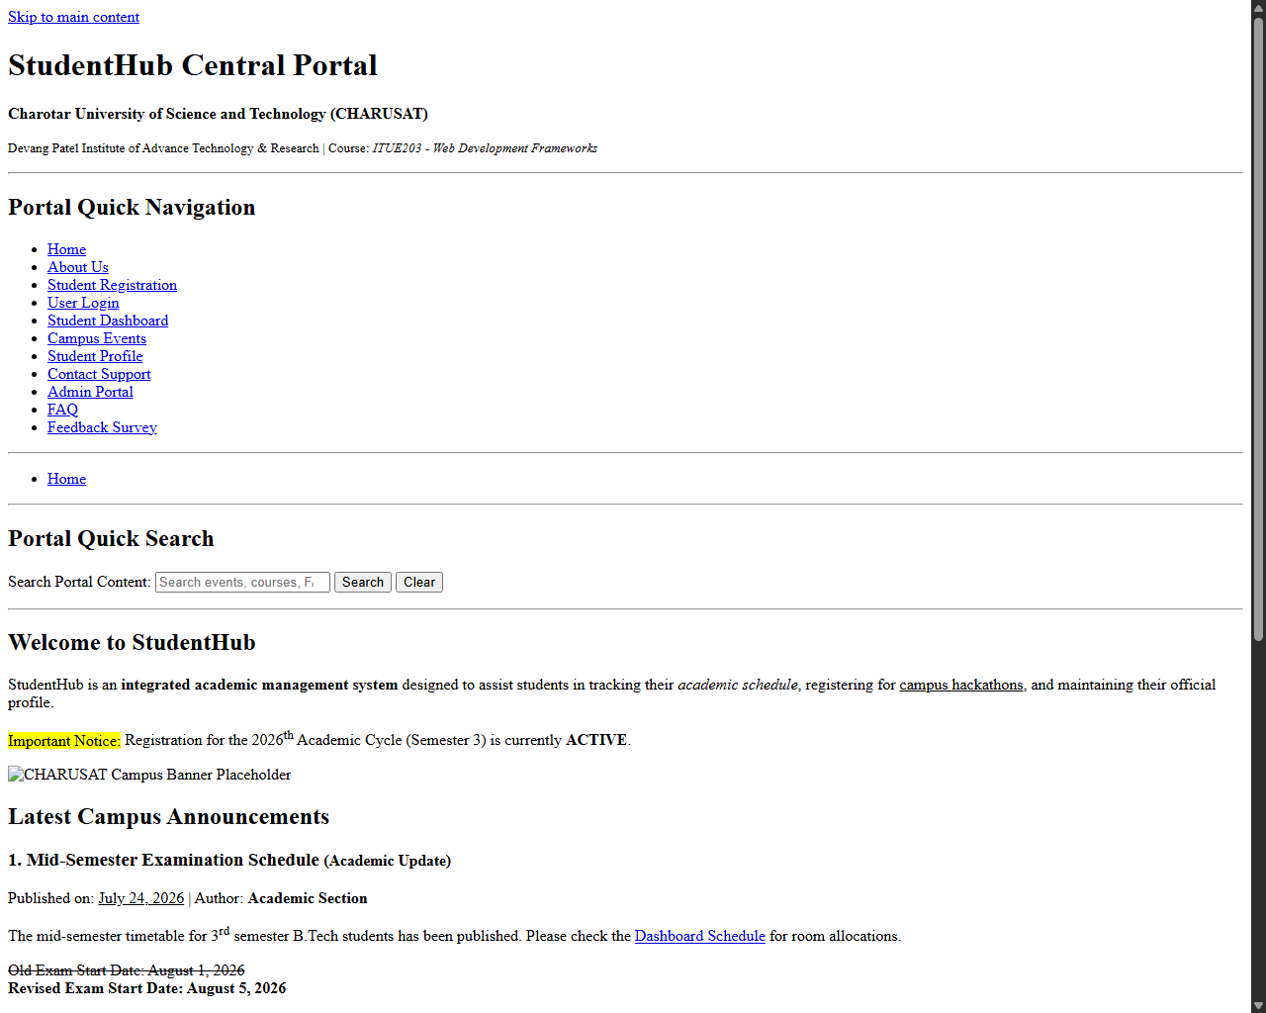
Figure: Browser rendering for Home Page

Output Slot: About Us Page (about.html)
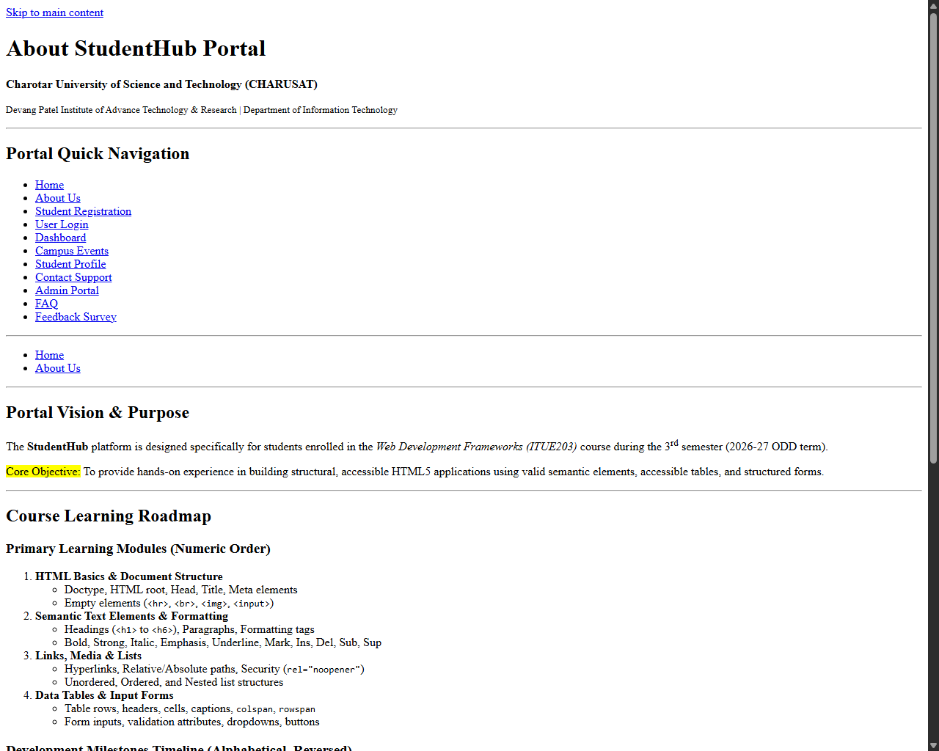
Figure: Browser rendering for About Us Page

Output Slot: Student Registration Page (register.html)
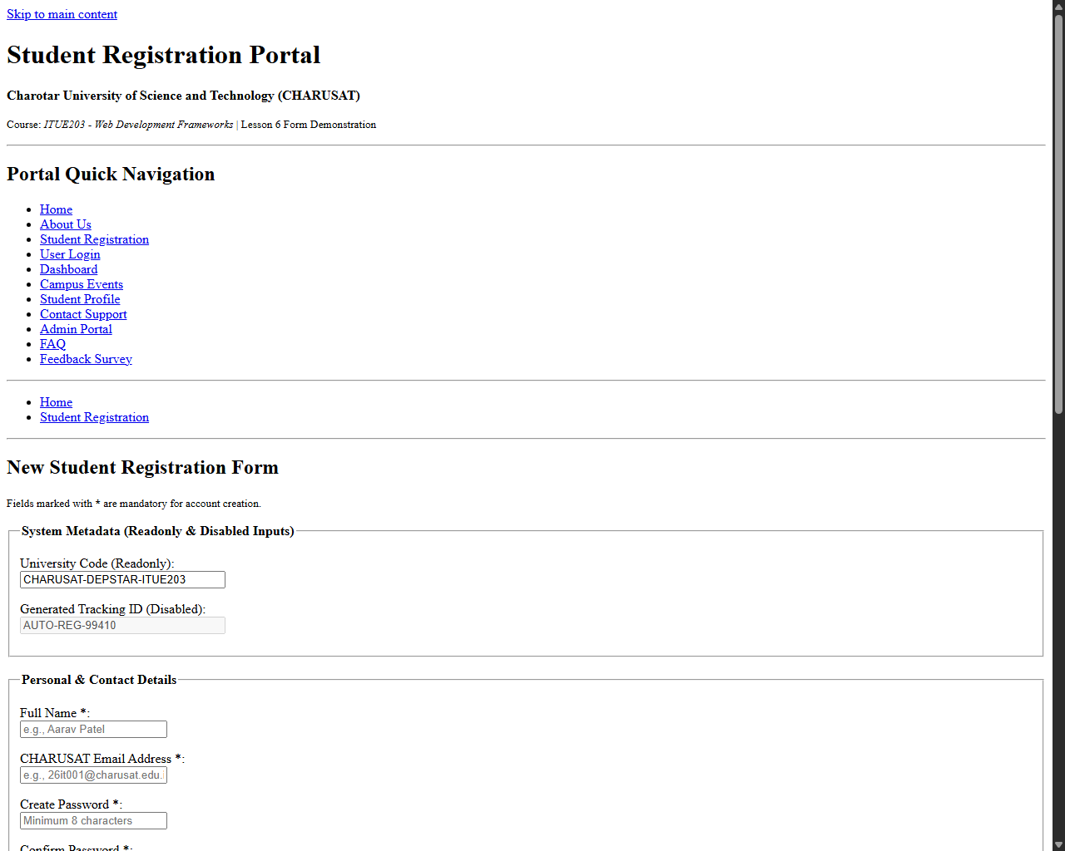
Figure: Browser rendering for Student Registration Page

Output Slot: User Login Page (login.html)
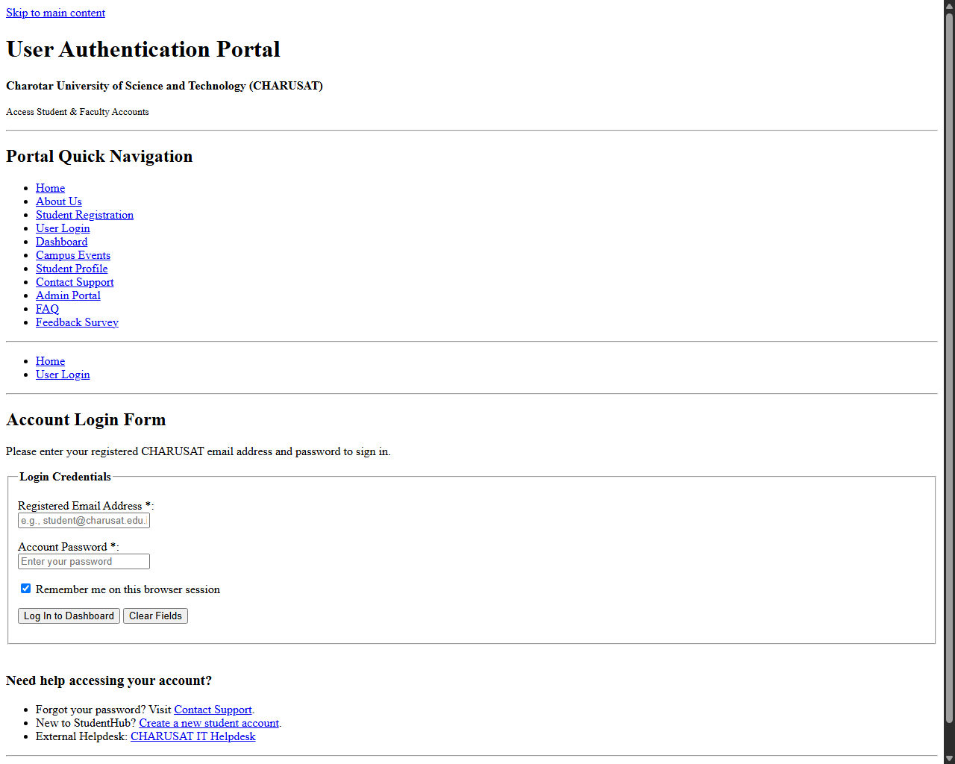
Figure: Browser rendering for User Login Page

Output Slot: Student Dashboard Page (dashboard.html)
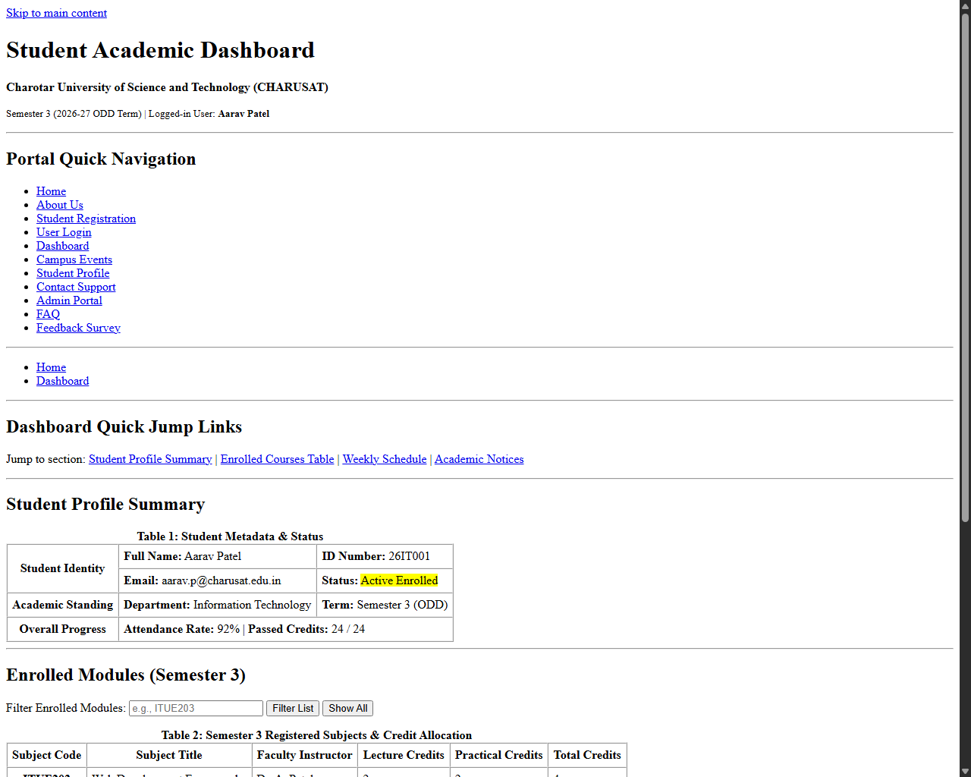
Figure: Browser rendering for Student Dashboard Page

Output Slot: Campus Events Page (events.html)
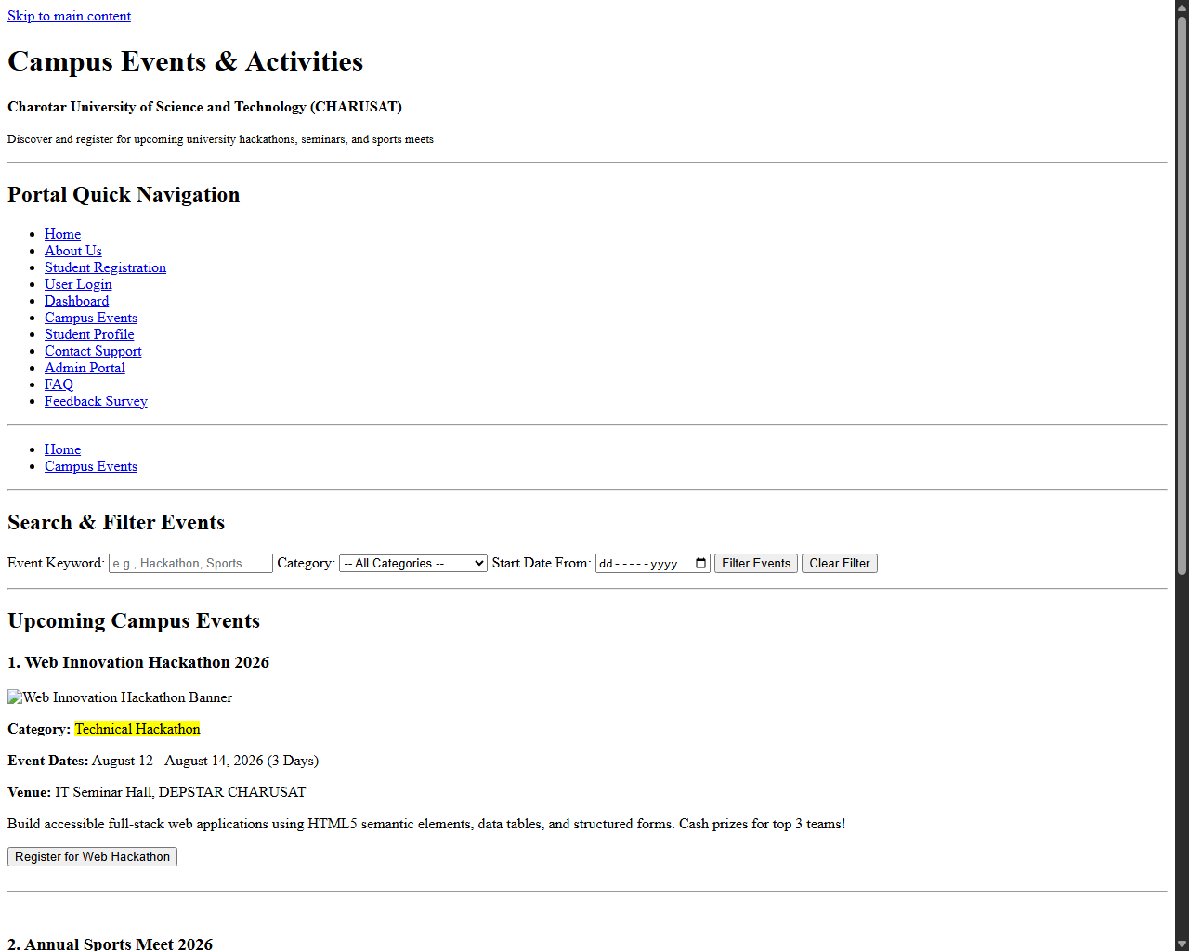
Figure: Browser rendering for Campus Events Page

Output Slot: Student Profile Page (profile.html)
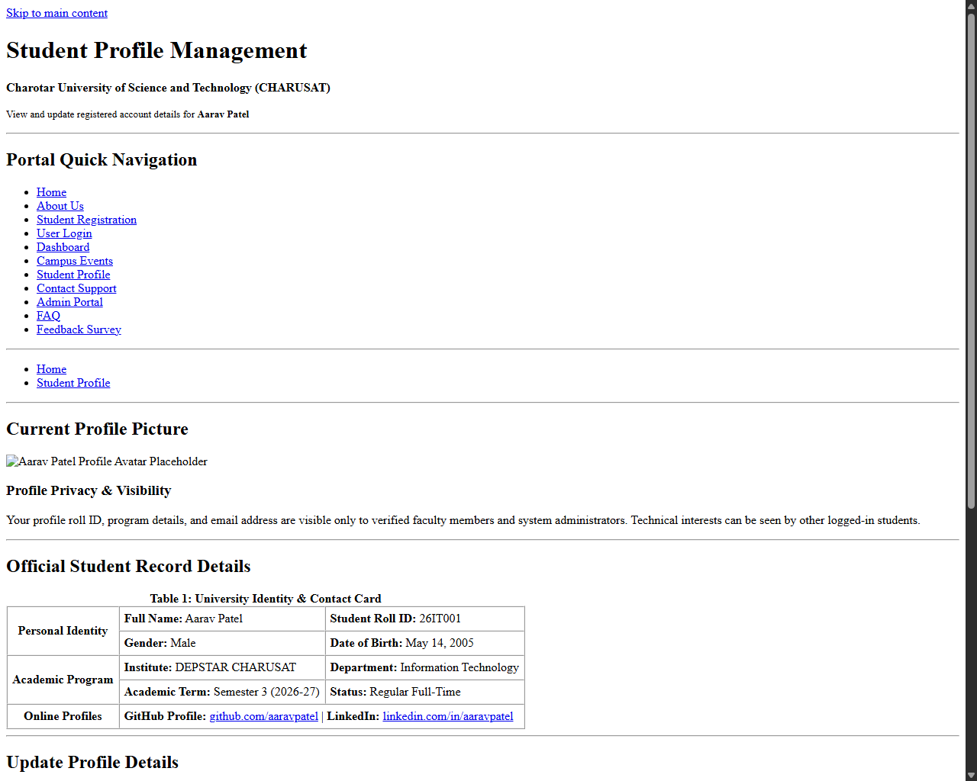
Figure: Browser rendering for Student Profile Page

Output Slot: Contact Support Page (contact.html)
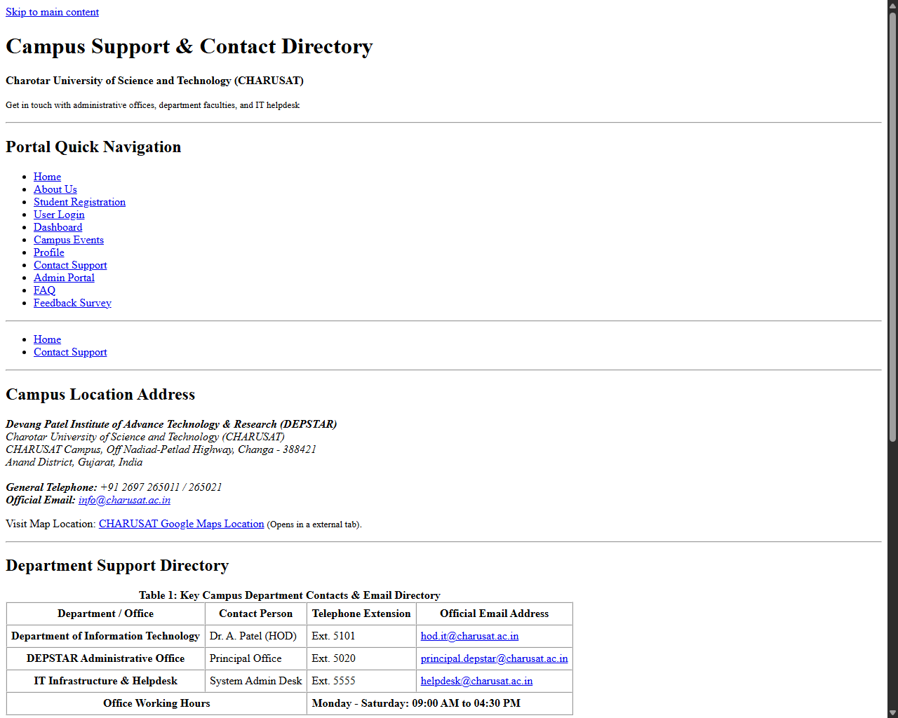
Figure: Browser rendering for Contact Support Page

Output Slot: Admin Portal Page (admin.html)
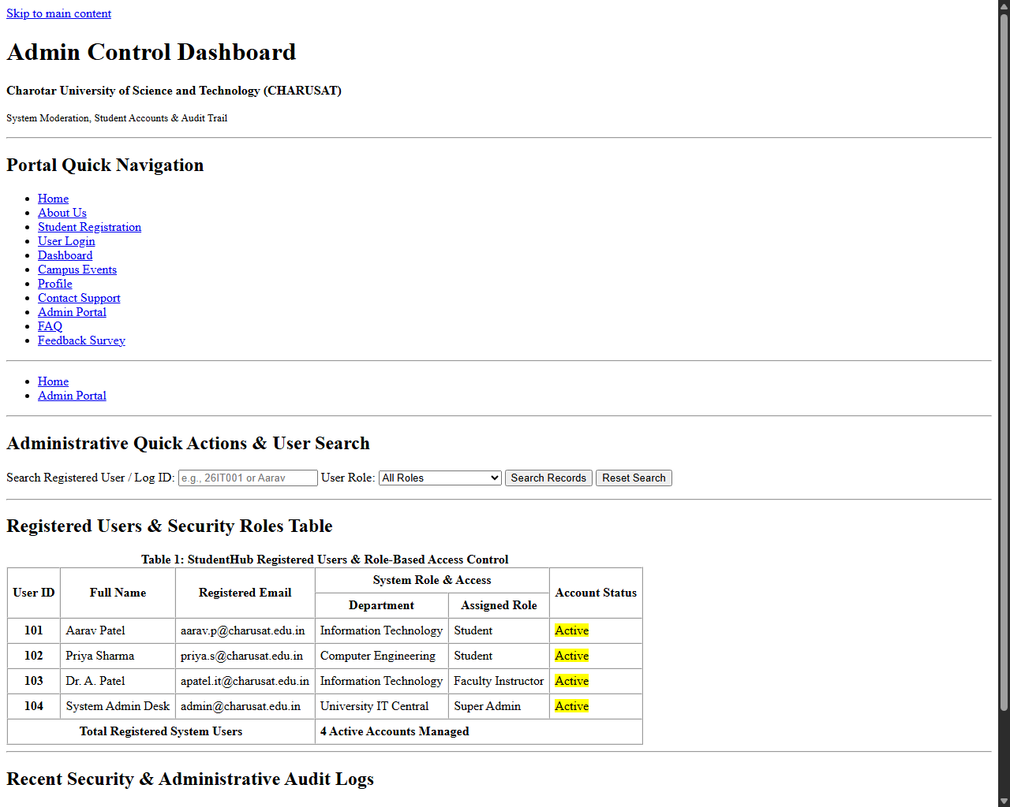
Figure: Browser rendering for Admin Portal Page

Output Slot: FAQ Page (faq.html)
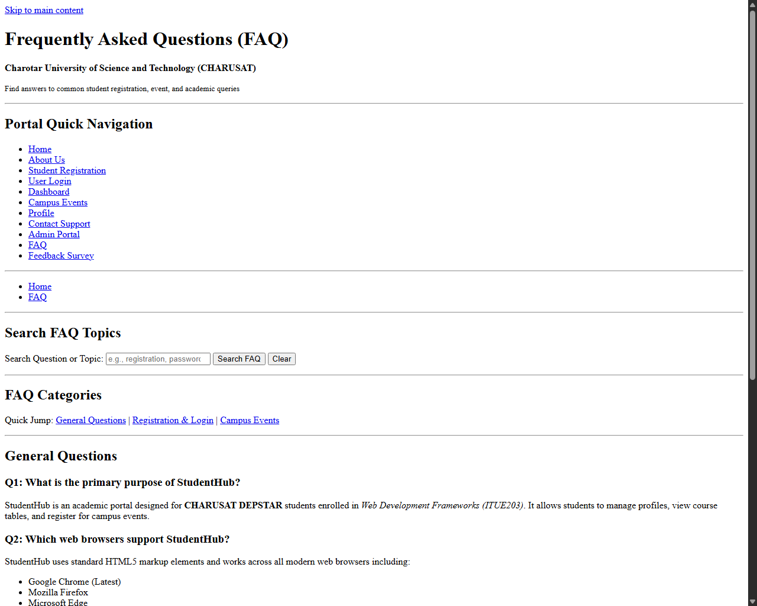
Figure: Browser rendering for FAQ Page

Output Slot: Feedback Survey Page (feedback.html)
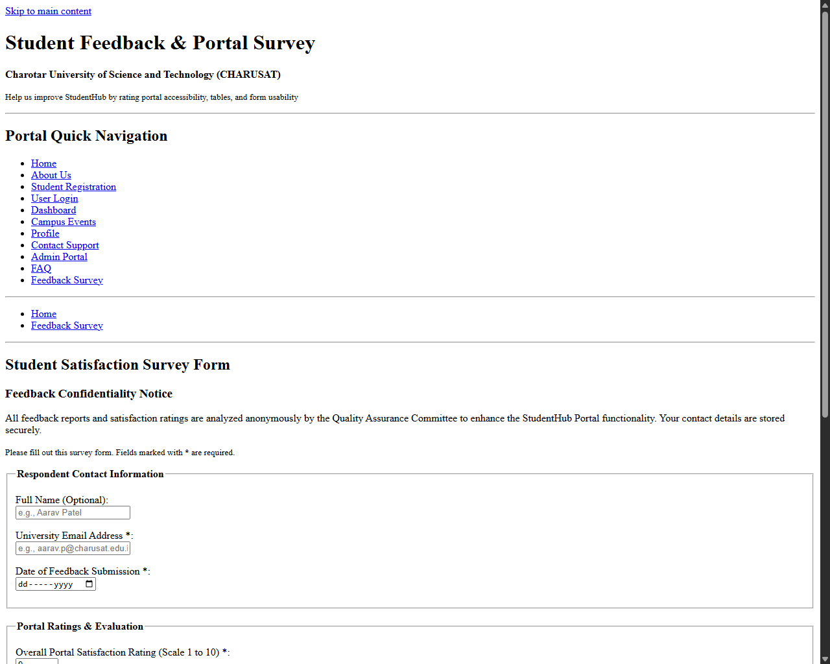
Figure: Browser rendering for Feedback Survey Page

Output Slot: Accessibility Keyboard Navigation & Focus State Verification
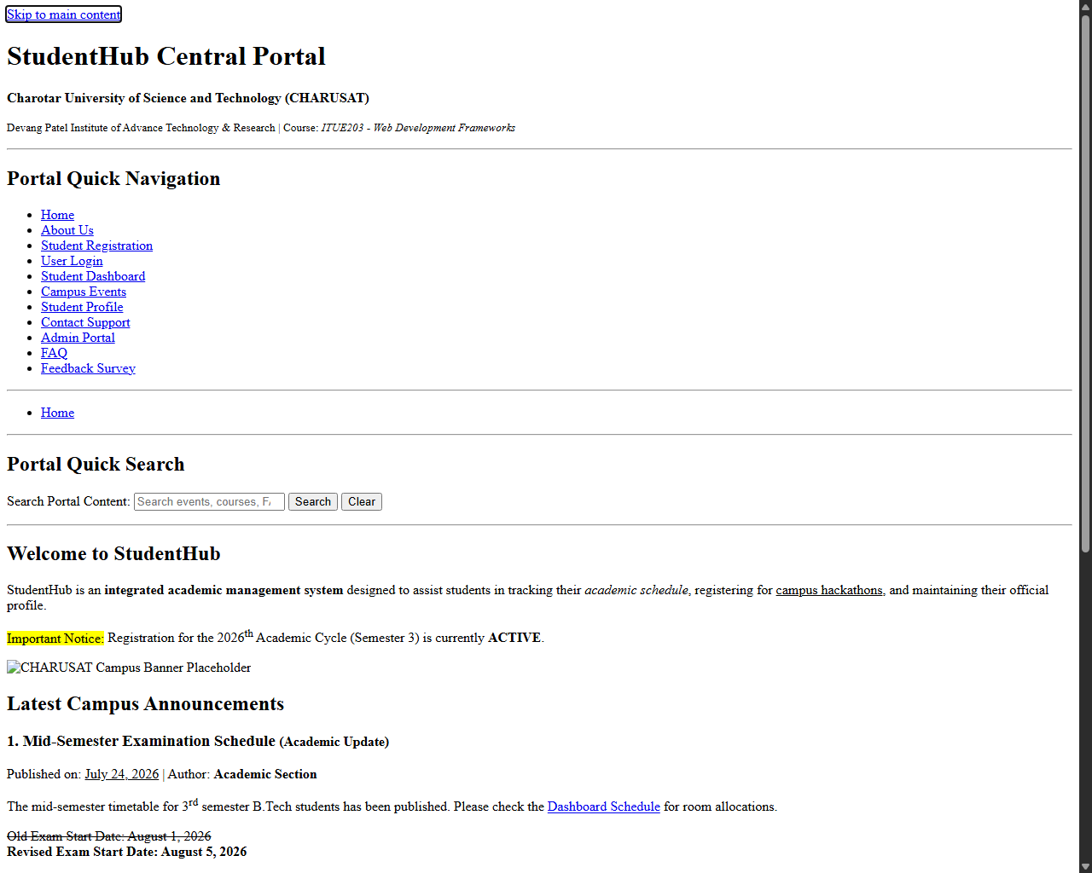
Figure: Skip link focused with default browser outline verifying keyboard navigation functionality

